Baldwin, Joshua; Chocron, Enrique; Dawson, Emily; Hernandez Chapa, Andres; Way, Joseph
FAMU-FSU College of Engineering 2525 Pottsdamer St. Tallahassee, FL. 32310

Team 518: NASA-MSFC - Lunar Surface Project 2
4/21/2023

Abstract
Wheeled rovers become unstable on the Moon because of the diverse terrain. The surface consists of regolith, a loose mixture of dust and gravel, that is small and sharp, which ruins equipment on the moon. The task is to see if a novel form of movement would be useful on the lunar surface. This project attaches a novel foot and ankle joint to Dr. Clark’s ET-Quad, a four-legged robot meant to travel over different surfaces. The design limits points of failure and mitigates regolith interference. The foot relieves slipping problems through extrusions on the bottom to increase grip. The traction feature has Rowed Spikes, which has a coefficient of dynamic friction of 1.11 and provides ease for manufacturing. The foot models a snowshoe by using a lattice grid to decrease pressure on the surface and reduce shifting regolith. The team performed drop tests to determine the best lattice design. During the drop test, cameras view the surface impact to analyze the change in depth and the plumes of regolith created. The lattice design with a 60% reduction per unit area has the best characteristics, including a penetration depth of 3.57 mm from experimental results. For movement, the ankle joint will attach to a leg from ET-Quad for a Boom Test. This confirms endurance and future integration with the robot. The final selected design has a lattice that causes the least regolith disturbance, which combines with traction extrusions that supply the greatest resistance to slipping, and unification with ET-Quad.

Keywords: Regolith, lattice, plumes, slip

Acknowledgement

Team 518 would like to thank all the advisors, professors, and peers that helped to make this project successful. A huge thank you to NASA-MSFC for their support, resources, and advice. Team 518 wants to specifically acknowledge Dr. Michael Zanetti and Arthur Werkheiser for their time and help guiding the project.
Secondly, Team 518 would like to thank Dr. Jonathan Clark and his team at the CISCOR lab for their time, guidance, and help through all the different testing stages of this project.
Next, we would like to thank Dr. Shayne McConomy for his support and advice throughout this project and for making this project possible. We would like to thank Pro Hruda for his help with the team’s purchasing and manufacturing needs.

Table of Contents

Abstract ii
Acknowledgement iii
Table of Contents iv
Notation xiv
Chapter One: EML 4551C 1
1.1 Project Scope 1
1.1.1 Project Description 1
1.1.2 Key Goals 1
1.1.3 Assumptions 1
1.1.4 Markets 2
1.2 Customer Needs 3
1.3 Functional Decomposition 6
1.3.1 Introduction 6
1.3.2 Discussion of Data Generation 6
1.3.3 Action and Outcome 7
1.3.4 Hierarchy Chart 7
1.3.5 Discussion 8
1.3.6 Cross Reference Chart 9
1.3.7 Connection to Systems 10
1.3.8 Smart Integration 11
1.3.9 Function Resolution 12
1.4 Target Summary 14
1.4.1 Derivation of Targets 14
1.4.2 Critical Targets/Metrics 19
1.4.3 Method of Validation 20
1.3.4 Discussion of Measurement 21
1.5 Concept Generation 25
1.5.1 Medium Fidelity Concepts 25
1.5.2 High Fidelity Concepts 30
1.5.3 What has Changed? 34
1.6 Concept Selection 34
1.6.1 House of Quality 34
1.6.1 Pugh Charts 37
1.6.3 Analytical Hierarchy Process (AHP) 39
1.6.4 Final Selection 42
1.7 Spring Project Plan 44
Chapter Two: EML 4552C 45
2.1 Project Scope Restatement 45
2.1.1 Project Description 45
2.1.2 Key Goals 45
2.2 Experimental Setups 45
2.2.1 Regolith Displacement Test Assembly 45
2.2.2 Traction Test 49
2.2.3 Movement Test 50
2.3 Results and Discussion 53
2.3.1 Results from Drop Test 53
2.3.2 Results from Traction Test 56
2.3.3 Results from Movement Test 58
References 63
Appendix A: Code of Conduct 64
Mission Statement 64
Team Roles and Obligations 64
System Integration Engineer - Andres Hernandez Chapa 64
Project and Test Engineer - Emily Dawson 65
Quality and Design Engineer - Joshua Baldwin 65
Software and Design Engineer - Joseph Way 66
Manufacturing and Design Engineer - Enrique Chocron 66
Communication 66
Meetings and Attendance Policies 67
Dress Code 67
Resolving Issues 67
Document Amendments 68
Statement of Understanding 68
Appendix B: Functional Decomposition 69
Appendix C: Target Catalog 72
Appendix D: 100 Concept Ideas 74
Appendix E: Concept Selection AHP Charts 77
Appendix F: Operations Manual 80
Appendix F.1– Project Overview 80
F.1.1 – Project Description 80
F.1.2 – Project Overview 81
F.1.3 – Key Goals 81
F.1.4 – Assumptions 82
Appendix F.2 – Regolith Simulant 82
Appendix F.3 – Penetration Depth and Plume Profile Detection 83
F.3.1 – Overview 83
F.3.2 – Prerequisites 84
F.3.3 – Regolith Displacement Test Assembly 85
F.3.4 – Regolith Displacement Test Assembly: Test Assembly 87
F.3.5 – Experimental Procedure 88
F.3.6 – Data Acquisition for RDTA 89
F.3.7 – Post-Experimental Data Processing 92
F.3.8 – Troubleshooting for RDTA 95
Appendix F.4 – Traction Test 97
F.4.1 – Parts and Components 97
F.4.2 – Experimental Procedure 98
F.4.3 – Static Coefficient of Friction 98
F.4.4 – Dynamic Coefficient of Friction 98
F.4.4 – Calculations 99
F.4.5 – Troubleshooting for Traction Test 99
Appendix F.5 – Final Design and Integration with ET-Quad 100
F.5.1 – Overview 100
F.5.2 – Final Design 100
F.5.3 – Components and Integration 100
Appendix G: Engineering Drawings 102
Appendix H: Risk Assessment 117
Appendix I: Calculations 130
Appendix J: Plume Data Code 131

List of Tables
Table 1: Stakeholders Table 2
Table 2: Customer Needs 4
Table 3: Cross Reference Table 9
Table 4: Critical Targets and Metrics 19
Table 5: Binary Pairwise Comparison Chart 35
Table 6: House of Quality (HOQ) 36
Table 7: Pugh Chart with Yutu 2 as a datum 37
Table 8: Pugh Chart with Spider as a datum 38
Table 9: Pugh Chart with 4 legged (wheel) as a datum 39
Table 10: Criteria Comparison Matrix 41
Table 11: Criteria Comparison Matrix 41
Table 12: Finalized Matrix 42
Table 13: Functional Decomposition table 69
Table 14: Target catalog (lunar surface) 72
Table 15: Target catalog (Earth conditions) 72
Table 16: Static and dynamic coefficients of friction 130

List of Figures
Figure 1: Hierarchy Chart 8
Figure 2: Flow Chart of Functions 12
Figure 3: Concept 1 25
Figure 4: Concept 2 26
Figure 5: Concept 3 28
Figure 6: Concept 4 29
Figure 7: Concept 5 30
Figure 8: Concept 6 31
Figure 9: Concept 7 32
Figure 10: Concept 8 33
Figure 11: Final Concept Selected 43
Figure 12: Spring Project Plan 44
Figure 13: Foot sample with 40% area removed from unit square 46
Figure 14: Assembled RDTA 47
Figure 15: Data Acquisition for Plume Data 48
Figure 16: Team 518 Conduction the Traction Test at NASA-MSFC 50
Figure 17: Boom Test Setup at the CISCOR Lab 51
Figure 18: Experimental Setup for the Boom Test Utilizing a Hopping Gait 51
Figure 19: Boom Test for Walking Gait on Flat Ground 52
Figure 20: Boom Test Walking Gait on Regolith Simulant 52
Figure 21: A Frame from RDTA Drop Test 53
Figure 22: Plume Percentage vs. Area Subtracted from Foot Sample 53
Figure 23: Penetration Depth vs. Area Subtracted from RDTA Results 54
Figure 24: Mass and Sinking vs. Area Reduction 55
Figure 25: Coefficients of Friction vs. Traction Design 57
Figure 26: The Spiked and Rowed Spike Traction Designs 57
Figure 27: Larger Retraction Gait Map 59
Figure 28: Torque vs. Time Data for a Walking Gait at 2.75 HZ 60
Figure 29: Final Achilles Model 61
Figure 30: Functional Decomposition chart 69
Figure 31: Functions flowchart 71
Figure 32: Function calculations 73
Figure 33: AHP Charts 78
Figure 34: Final rating matrix 79
Figure : Proposed Design 80
Figure 36: Regolith Simulant 518 83
Figure 37: Regolith Displacement Test CAD Assembly 85
Figure 38: Regolith Container 86
Figure 39: Support Piece 86
Figure 40: Guide 87
Figure 41: Dropping Device 87
Figure 42: RDTA Data Acquisition Set-Up 90
Figure 43: Dropping Device with Measurements 91
Figure 44: RDTA Template Set-Up 92
Figure 45: Regolith Plume Confidence Levels 93
Figure 46: Example Traction Design 98
Figure 47: The area of integration 101
Figure 48: Addition of the lattice and traction to the foot 101

Notation
$R$ Resolution
$n$ Number of bits
$F_{f}$ Friction Force
$μ_{s}$ Coefficient of Static Friction
$μ_{k}$ Coefficient of Kinetic Friction
$N$ Normal Force

Chapter One: EML 4551C

Project Scope

1.1.1 Project Description
Our objective was to develop a system that can successfully explore and maneuver through regolith in the lunar poles.

1.1.2 Key Goals
The main goal of this project is to ensure that the system can get from one point to another without getting stuck. It is most important that this device can transverse the lunar surface. This project aims to be lightweight, low cost, and easy to assemble. Since temperature gradients are one of the greatest struggles with lunar devices, having a good understanding of the design of the thermal management of the system is important. It may not be possible within our budget and time to successfully make the device thermally maintained, but it will be accounted for.

1.1.3 Assumptions
Our team made various assumptions to constrain the scope of this project to ensure the project could be completed by the end of the year. After speaking with our sponsor, it became evident that it is near impossible to simulate the moon's conditions here on earth. It is assumed the device will be tested with Earth-like conditions, specifically regarding gravity. The team will explain changes that need to be made to the system so that it can function on the moon. This product will not be
expected to maneuver anything steeper than a 40° incline. Lastly, the device will need to be able to survive the lunar nights and lunar days. It will be shut down to conserve energy and prevent hardware malfunction during the extreme periods of lunar day and lunar night, rather than continuing exploration.

1.1.4 Markets
The development of this project is primarily targeted for commercial and governmental space agencies. The product will fulfill the needs of entities such as NASA, SpaceX, and Blue Origin through the exploration of various locomotion methods for the purpose of regolith navigation. Secondary markets for this project include universities, museums, and other international space agencies. Regardless of whether this project will make it to the lunar surface or not, it can be used as an educational tool for future experimental designs.

1.1.4.1 Stakeholders
Table 1: Stakeholders Table
 | Investor | Decision Maker | Advisor | Receivers
Sponsor  NASA-MSFC | X |  | X | X
Managers  Dr. Shayne McConomy, Caterina Arnold, Saralyn Jenkins, and Jordan Steverson |  | X | X
Experts  NASA-MSFC, Dr. Jonathan Clark |  |  | X | X
Operators  Commercial and governmental space agencies |  |  |  | X
General Readers  Dr, Jonathan Clark, commercial and governmental space agencies, and research laboratories |  |  | X | X

Note: Some of the stakeholders can impact the project in more ways than one. For example, managers can be advisors and decision-makers.

1.2 Customer Needs
For a novel design to be conceptualized, the customer needs must be established. To begin our preliminary design phase, information regarding the composition of the soil, past rovers, and new technology had to be researched and discussed with our customer. The team sought this information during a meeting with the representative, Dr. Mike Zanetti, an expert regarding the lunar surface from our project’s sponsor, NASA-MSFC. The engineers there have studied this terrain for decades. They bring valuable knowledge and have their own testing facilities. The table below shows the questions we asked, the sponsor’s answers, and how the team interpreted those answers.

Table 2: Customer Needs

Question | Answer | Interpretation
What do current rovers struggle with the most while moving across the lunar surface? | “Around 90% of the regolith on the moon is the same and it is below 1 mm in diameter. However, there are random chunks of big rocks that can be as big as a boulder.” Dr. Zanetti | Our design will need to handle diverse types of terrain and deal with inconsistencies on the surface.
Is there a method of traveling through regolith that you have seen to be the most effective? | “We know that wheels are the most effective while transverse the moon. However, it would be cool to see something unique.” Dr. Zanetti | Wheels are reliable, but our design can be more creative and involve complex motions.
What issues do you see equipment on the moon have? | “Thermal management is a huge issue for equipment on the moon and is a huge design factor.” Dr. Zanetti | The design involves a temperature management system for uniform temperature distribution.
What would be a reasonable operating temperature for the system? | “The temperature distribution varies a lot. It is better to look at a thermal map of the moon to determine the operating temperature of the system. For missions in the poles, it is possible to have a thermal gradient across the system depending on its orientation.” Dr. Zanetti | The materials of the system are capable of withstanding a given temperature range for a specific location on the moon.
Do current rovers work at any latitude of the moon? | “They do not. Most of the lunar rovers are designed to work near the equator since their photovoltaic cells are oriented horizontally with respect to the lunar surface.” Dr. Zanetti | The position of the solar panel is a function of the system’s latitude and orientation. Choose the deployment location wisely.
Can we treat regolith as a fluid? | “Swimming could be an alternative approach but is not the best idea since just a small layer could be treated as a fluid. The rest of the lunar regolith will act as a solid portion.” Dr. Zanetti | Layers of regolith become tightly packed below a small depth. Deep portions of regolith may be treated as a fluid, but most of the surface cannot be assumed to behave as a fluid.
What task does our system have to accomplish? | “There are a few focus areas that NASA and the Lunar Surface Innovation Consortium are looking for such as in-situ resource utilization, exploration in extreme environments, extreme access, or excavation and construction.” Dr. Zanetti | The system completes a specified task established by the team.

Dr. Mike Zanetti was able to answer all our questions effectively. This allowed the team to understand the purpose of the system and the path we must follow. From the needs described by the customer, we interpret the design to be a system that can traverse varying depths of lunar regolith while maintaining a thermal distribution for a particular region of the lunar surface.

1.3 Functional Decomposition

1.3.1 Introduction
Functional decomposition is the process of resolving a functional relationship between its constituent parts in a way that the original function can be re-created from those parts (Mo, 2014). Here, the project’s physical actions and outcomes are broken down into broad systems. After that, more specific functions are organized into distinct categories. For the purposes of this project, these categories are Structural Support, Mobility Mechanism, Thermal Management, Power Systems, Avionics, and Guidance, Navigation, and Control (GNC). These major functions are shown in a hierarchy chart, in which each category has its minor functions that represent specific tasks that the system must accomplish.

1.3.2 Discussion of Data Generation
The six major functions of our system were determined from understanding the goal of the project, which was a combination of the sponsor’s interests and ideas during several meetings. In general, we look to create a system capable of transvers the lunar surface in one of the poles of the Moon and see if we can implement an alternative mobility method.
With this information, and with interpretations of our customer's needs, we determined that a power system will be required to distribute the energy to different systems in the design. To keep both the electronics and the structural design working, a thermal management system would be required to tackle the fluctuating temperatures at the poles of the moon, especially ext. An avionics system will be required for the management of multiple systems, which also includes a Guidance, Navigation & Control (GNC) system for communication and navigation purposes. The main systems that the team plans to tackle are the structural design and the mobility mechanism.
After the major functions were identified, the team determined which actions that major function would need to complete. These actions can be defined as the minor functions of the system. Some of them may be a subset of one or more major functions.

1.3.3 Action and Outcome
The main goal of the project is to develop a system that can successfully traverse the lunar surface at the poles. A machine must be structurally stable and move in an innovative way. It will need to be able to navigate through regolith and ascend/descend surfaces up to 30 degrees. The rover will utilize materials to enhance its structural stability so that it can withstand the temperatures on the moon to prevent any malfunctions.

1.3.4 Hierarchy Chart
The following chart shows each major function, and the minor functions that primarily coordinate with it. Later, a cross reference chart will be shown to see how the minor functions can still apply to more than one major function.

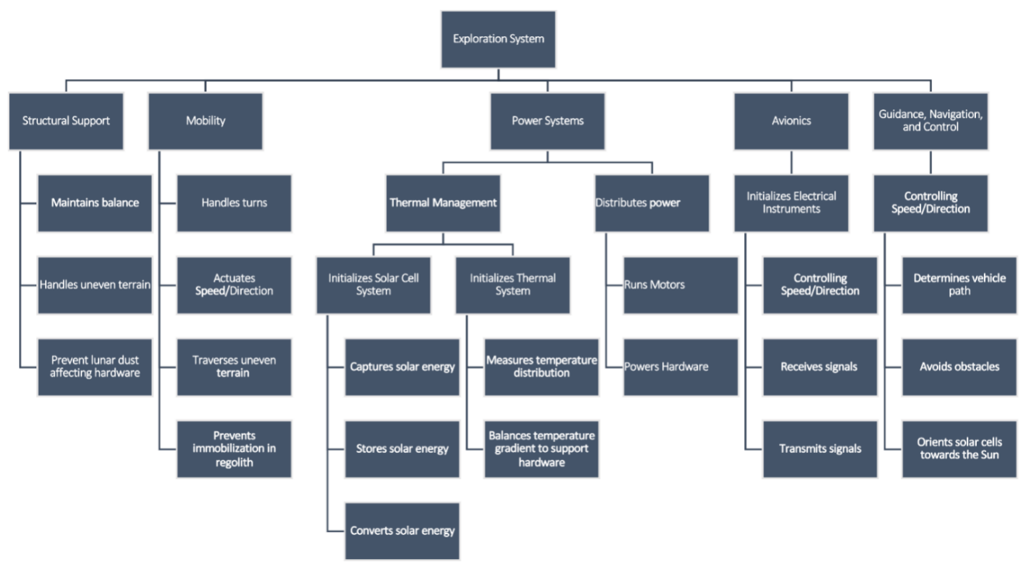
Figure 1: Hierarchy Chart

1.3.5 Discussion
Figure 1, the hierarchy chart, helped split the major functions into simpler tasks for the team to focus on. The first section of the hierarchy chart is structural support. The structure of the rover is important because it needs to be able to deal with lunar gravity, withstand fluctuating temperatures, and be stable enough to not fall over when the solar panels are deployed.
The next major function is mobility. With a surface covered in very fine soil and dust as fine as talcum powder, moving across the surface of the moon will be challenging. This function focuses on the turning, speed, and handling of the rover over uneven surfaces. The mobility mechanism focuses on getting the rover through the inconsistent terrain without getting stuck and having a way to remove itself in case it does get stuck.
The power systems will be used for two aspects of the rover, the distribution of power and thermal management. Distribution of Power focuses on the action required to move power to different sub systems in the rover, like starting the motors that control the wheels, or the mechanisms associated with orienting the solar panels. Thermal Management focuses on initializing the thermal systems, to measure the temperature of the systems in the rover and adjust it to prevent heat damage. Another large part of thermal management surrounds the solar cell system, which will capture, convert, and store solar energy.
The last major function is Avionics. Its purpose is to initialize the electrical instruments and Guidance, Navigation, and Control (GNC). Initialize the Electrical instruments will transmit and receive signals from the rover or user, read data from the sensors of the rover, as well as reading its location by determining the selenography coordinates. GNC is the main catalyst for controlling the location of the rover while using the selenographic coordinates. The coordinates can be used to control the orientation of the solar cell so that they always face the sun to capture the most amount of solar energy.

1.3.6 Cross Reference Chart
The purpose of the following chart is to show the relative importance of the specific functions obtained in the hierarchy chart and to determine how many systems they appear in.
Table 3: Cross Reference Table
 | Function Class
 | Structural Support | Mobility Mechanism | Thermal Management | Power System | Avionics | GN&C
Controls Speed |  | X |  |  | X | X
Controls Direction |  | X |  |  | X | X
Handles turns | X | X |  |  | X | X
Maintains balance | X | X |  |  | X
Handles uneven terrain | X | X
Captures solar energy |  |  | X | X
Stores solar energy |  |  | X | X
Converts solar energy |  |  | X | X
Measures temperature distribution | X |  | X |  | X
Balances temperature gradient to support hardware | X |  | X | X | X
Receives signals |  |  |  |  | X
Transmits signals |  |  |  |  | X
Determines vehicle selenographic coordinates |  |  |  |  | X | X
Orients solar cells towards the Sun |  | X | X | X | X
Prevents immobilization in regolith | X | X |  |  |  | X
Prevents lunar dust affecting hardware | X
Distribute power |  |  |  | X
Avoids obstacles |  | X |  |  |  | X

1.3.7 Connection to Systems
After reviewing the cross-reference chart and discussing with our advisor, we determined the priority of each system and functions. The systems rank as follows: Mobility Mechanism, Structural Support, Thermal Management, Power System, Avionics, GNC. We decided that Mobility Mechanism and Structural Support should be at the top of our ranks because these two systems align the most with our project goal, which is to develop a system that can successfully maneuver through regolith to explore the lunar poles. So, our priority is to develop a good mobility mechanism to achieve effective traversal of our rover, followed by providing a reliable structural support system to our rover to ensure it is properly supported by a suitable framework.
The system must be able to withstand the drastic temperature changes on the moon, especially the cold temperatures at the poles during the night, which makes our Thermal Management system essential for the survival of our rover. As for our Power System, Avionics, and GNC systems, while essential for our rover, our sponsors (NASA) already have extensive resources in these areas. So, we have decided not to focus so much on developing these systems, and instead using their resources and integrating them into our system itself, while focusing more on the other functions.

1.3.8 Smart Integration
The minor functions developed for this system have classifications from multiple major functions stemming from their purposes. Since the goal of this system will be to develop a novel mobility method, the minor functions such as controlling the speed and direction have components within 3 classes of major functions: Mobility Mechanism, Avionics, and GNC. The main driving factor of the motion will be the mechanism enabling that motion. Avionics and GNC come secondary because without the function of mobility, the system will not move. The movement will be the primary focus of this development. However, the Avionics and control systems are critical to the functionality of the assembly.
Power distribution to avionics is pertinent for electrical components. On the lunar surface, power must be collected, stored, and transferred to parts throughout. Thermal management is going to be the key to keeping the system alive by maintaining the health of the system through the lunar night and day cycles. For real applications on the surface, the product must measure the temperature distribution and balance the temperature gradient. Without this lifeline, the system would not be able to receive or transmit signals back to Earth. Communication must not be interrupted with the system. Even though mobility is our focus for this project, the factors of thermal management, avionics, GNC, and power distribution must be taken into consideration.

1.3.9 Function Resolution
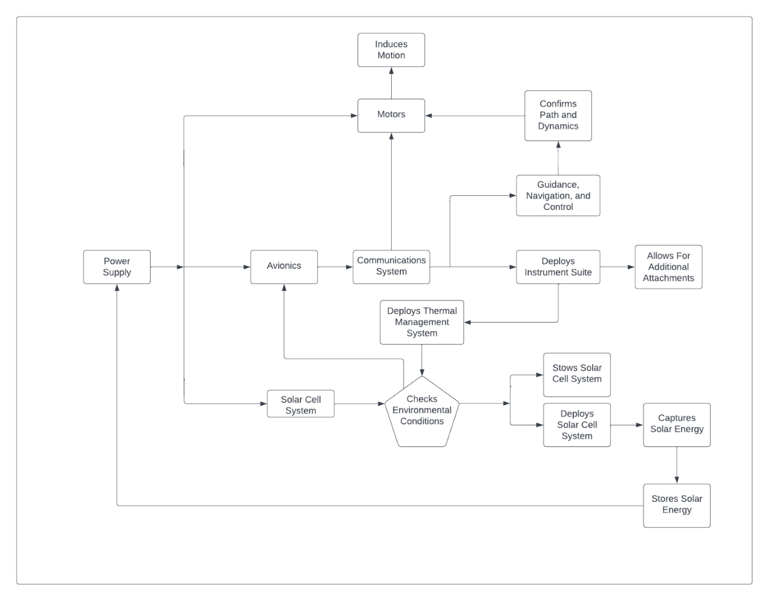
Figure 2: Flow Chart of Functions

The function resolution is the smallest element of a design system. For this system, the smallest element needed is mobility. Without creating motion, this project accomplishes nothing. In order to create this motion, the assembled components involve a power system, avionics, control system, environmental checks, structural support, and mobility mechanisms. These components must work together for motion to occur.
Figure 2 is a chart showing the flow of energy and connections between every system for this project. It is read starting on the left side with the power supply. Power is distributed to the avionics, motors, and solar cell systems. These individual systems will need their own power requirements but are interconnected. The avionics allows communication from the ground to the system on the lunar surface and vice versa. Powering the motors establishes communication to the limbs and produces motion. Once environmental conditions are checked, the system will decide if it continues with the mission or stows the instrument suite that deploys. When the solar cell system is deployed, it captures solar energy for the power system.

Target Summary
Targets and metrics help quantify important functions that make projects successful. These aspects are based off the customers' needs and the key goals. Targets are necessary to ensure the product will be something useful to the customer. The metrics that have been identified begin to narrow down the scope by constraining the design process. Concept generation will follow, and these quantities will guide the development. Every target is tabulated in Appendix C. These targets give numerical values associated with each minor function.

1.4.1 Derivation of Targets
Innovation of a novel movement mechanism begins with elementary dynamics. Systems involving locomotion consider the vectors occurring at every instantaneous moment, such as the speed and direction of the entity. To quantify through measurements, resolutions of functions are used as a baseline for accuracy. A resolution is the smallest incremental value used for recording data. The importance of using resolutions to quantify our measurements is to prevent aliasing from occurring. Mathematically, a device’s resolution, R, is defined by the operating range divided by the number of binary bits, n. This takes the form of equation (1):
$R=\frac{Range}{2^{n}}$ (1)
Benchmarking an Adafruit BNO055 inertial measurement unit (IMU) for specifications led to the derivation of the resolutions. This device was chosen because it has a triaxial14-bit accelerometer, a triaxial 16-bit gyroscope, a triaxial geomagnetic sensor, and reads ambient temperature in a single sophisticated package. The IMU will help control the system by reading the physical values of
acceleration, angular velocity, triaxial orientation, and temperature. Utilizing the geomagnetic sensor is out of the scope of this project, but the native instrument still has potential use. Measuring these attributes initializes feedback control. Feedback from the equipment is necessary to facilitate further motion.
The full calculations of the resolutions are found in Appendix C. The operating range for each function was chosen to represent the scope of this project. The values were chosen based on realistic extrema values the system should be within. All the resulting resolutions are given a 10% uncertainty.
Given a 14-bit accelerometer with customizable operations, the approximate range the system should withstand is ±4 times the gravitational acceleration, g. This results in an accelerometer resolution of 0.001g, which quantifies the minor function Handles Turns. The intent behind this is to prove the system handles higher gravitational effects on Earth before attempting to experiment in a low-gravity environment on the Moon. To measure velocity, the IMU will be used to capture the angular velocity and the change in coordinates over time from the absolute orientation quaternion (spatial rotation vectors) readings. The range of the velocity of the body will be within ±5$\frac{m}{s}$ and is measured from the 14-bit accelerometer. The resulting resolution is 0.001$\frac{m}{s}$. This is the smallest increment the velocity will measure and quantifies the minor function called Controls Speed.
Escaping scenarios of immobilization is critical for application on the lunar surface. To quantify immobilization, instantaneous velocity is used. To detect resistance and possible immobilization within a technical demonstration or on the lunar surface, the system will have a
nominal velocity for its main mode of travel. When the actual velocity is slower than 10% of the nominal speed, the system will try an alternate form of movement to attempt to increase the real speed back to the base value. The minor function, Prevents Immobilization in Regolith, captures the scenario of deep, loose regolith and the potential hazard of getting stuck.
The 16-bit triaxial gyroscope reads absolute spatial orientation in the directions of pitch, roll, and yaw. Although these directions are all read from the same device, they are all processed differently. The Adafruit BNO055’s datasheet stated the pitch operating range is ±180°, the roll operating range is ±90°, and the yaw operating range is 360°. From this, the pitch angle resolution, $R_{p}$, is calculated to be 0.005°, the roll angle resolution, $R_{r}$, is 0.003°, and the yaw angle resolution, $R_{y}$, is 0.005°. To classify future complex body orientation, the three minor functions, Controls Pitch, Controls Roll, and Controls Yaw must be treated independently. Roll angle is important to the development of this novel movement system, which includes traveling on uneven, sloped terrains. For example, if the angle is too large, the system will tip over from the gravitational field. The minor function, Maintains Balance, utilizes a target maximum roll angle of 30° for the system in its definition. The roll angle will be explicitly measured for proving this minor function.
To obtain temperature values, the IMU will read an ambient temperature 16-bit output from an operating range of 233.15 K to 358.15 K (-40°C to 85°C). The resulting temperature resolution, $R_{T}$, 0.002 K. The intent of choosing this IMU is to provide an example of how temperatures can be measured around the system and how it can be applied to the lunar surface. It is important that the temperature be measured accurately to ensure protection of the hardware. If this project is deployed on the lunar surface, it must have a thermal maintenance system that balances spikes in
the temperature gradient near hardware or from the extremities of the surroundings. The target for this function is quantified with the same temperature resolution but is focused on outliers in the gradient that prevent the system from staying in thermal equilibrium.
In order to have avionics, they need to have a dedicated volumetric space. Currently, the exact dimensions and placement of every unit is unknown. For this reason, a maximum volumetric space of 1 has been reserved to leave freedom within constraints. This is used to quantify Housing Technology. This is a large space, but the goal of this minor function is to encapsulate everything involving instrumentation, wiring, and motors, while simultaneously leaving creative options open for scalability within a unit volume. However, this minor function only covers the internal electrical components of the system. Additional attachments such as wheels, legs, or solar panels are not inside of this volume. The technology within will be shielded from the regolith. To test this protection, the minor function, Prevents Lunar Dust from Affecting Hardware, is quantified by a maximum allowable grain size of 10 𝜇𝑚. This size will defend the system from at least 90% of all lunar regolith. This comes from the understanding that the final product will most likely not be able to safeguard the technology 100% effectively.
Power and control systems are key to the survival of the project in extreme conditions. The minor function, Distributes Power, was crafted to specifically point at the power consumption levels by each subsystem. The target quantity is a 5% distribution error among the voltage used by the electrical parts. The intent is to provide feedback to confirm that the correct power is being directed to the right systems. Demonstrating control of the final product will be through a standard 8-bit controller with manual input. The minor function, Avoids Obstacles, quantifies the physical
output through the input of that controller. Visual outputs from the system will be from a LiDAR system, the Ouster OS 1-128, loaned from our generous sponsor. When applied to the lunar surface, manual control is not ideal. A lower powered system could be used as an alternative. Benchmarking the Ouster OS 1-64 gets the target range of 90 m and a field-of-view (FOV) of 45°.
On the lunar surface, the device must charge its batteries. The idea behind the minor function, Captures Energy, was to not limit the design by constraining the project to solar panels or rechargeable batteries. The quantifiable target for this is to have a minimum energy transfer efficiency of 70%. Electric vehicles typically have a 60-85% efficiency when charging and phones usually have a higher efficiency. The value of 70% efficiency appropriately fits what this system is trying to accomplish. Additionally, while the system is on the surface of the Moon, it must be able to communicate to ground control. Since manual control is not feasible in this situation, a theoretical target for the minor function, Communicates to Ground, is to have the product transfer pictures to ground control at a minimum of 1 frame per second (FPS). In a real application to the lunar surface, this system would send data confirming deployment and nominal ranges.

1.4.2 Critical Targets/Metrics
Table 4: Critical Targets and Metrics
Function | What is Being Measured | Metric
Controls Velocity | Velocity resolution of the system | 0.001$\frac{m}{s}$
Maintains Balance | Roll Over Angle | 30°
Prevents Immobilization in Regolith | Instantaneous Velocity Error | < 10 % Error
Prevents Regolith from Affecting Hardware | Maximum allowable grain size | 10 𝜇m
Avoids Obstacles | Appropriate Sensor (i.e.: LIDAR) | 90 m range

The summation of the minor functions will equate to the full system. Without certain components, however, the project will fail to operate. Critical functions have been identified to be the most important targets this assembly needs to achieve for the accomplishment of the main objective. The first critical target is Controls Velocity, which is quantified by the resolution metric of 0.001$\frac{m}{s}$. If the assembly cannot measure its speed, then it lacks feedback control. This concept directly applies to the additional resolutions defined in our targets. Another critical target is the system Maintains Balance. The quantification of this metric will be obtained from the future center of gravity (CG) location: the system should have at least a maximum roll angle of 30°. The initial situation given involved deep regolith, so Prevents Immobilization in Regolith, measured by an instantaneous velocity error of 10%, was identified as a critical target to constrain the scope. Since regolith has extreme variable grain sizes, a critical target of 10 𝜇𝑚 was chosen so the system Prevents Regolith from Affecting Hardware. The last critical target set is Avoids Obstacles, which will be quantified through the range of a LiDAR sensor. The target range is 90 m. This was identified as a critical target because of its impact on the survivability of the system in hostile environments. Preliminary estimations have led to the decisions made for these critical targets. Other critical targets may be found later in development.

1.4.3 Method of Validation
To determine each target is met, analyses will be validated through testing, where values will be extracted from fine hardware measurements. The discrete intervals for the quantifications are derived from the resolutions of instruments. Testing resolutions involves calibrating equipment and obtaining relevant data. Once the device is prototyped, a specific method of validation that will be used is to have the system travel along the length of a football field, make a turn, then retreat to the start. This process will be continuous to test the range and accuracy of the onboard avionics. The avionics will be governed by IMUs to detect absolute orientation and kinematics. The maximum roll angle of 30° will be validated through CG calculations, physically orienting the system for demonstration, and reading the IMU data.
The structural deterrence of regolith will be validated through submerging the system in various media. Upon completion of this test, the maximum grain size for the product’s tolerance to fine lunar dust will be found. This will be obtained by identifying the largest grain size to enter the structure. To validate the immobilization of the project, the device will be subject to resistive media testing. This method involves translating the product through mediums that act as fluids with variable properties. The intent is to have the system detect when resistance forces are large so alternate forms of movement can be used to help the system traverse extreme environments. Validating an operational LiDAR system will include an obstacle avoidance test where objects will be placed within range of the sensor and data will be processed. The motive is to demonstrate the potential for complete automation of this project in the future.

1.3.4 Discussion of Measurement
Physically measuring the dynamics of the system will involve the use of readily available technology. An Adafruit BNO055 absolute orientation IMU is to be used to collect this information. Validation of the target velocity resolution of 0.001$\frac{m}{s}$ will be read through the velocity vectors read by the IMU and coordinates originating from a specified point. The IMU does not measure linear velocity, however, obtaining angular velocity data in addition to changing position over time will combine to accurately calculate the body speed. Integrating an onboard GPS device to pair with stored velocity values will give two references to the real speed. The importance of gathering the data on these values would be to perform analysis for both understanding the characteristics of the system and for optimization purposes.
Since the Adafruit BNO055 reads triaxial absolute orientation, the balancing of the system will be analyzed from roll angle data and the CG. The IMU will quantify pitch, roll, and yaw in intervals of the resolution angles. One disadvantage from using this device is that it will only operate in temperatures between 233.15 K to 358.15 K (-40°C to 85°C). The decision to choose this device stems from the drive for demonstration. This is intended for educational purposes to inform actual deployment to the lunar surface, but not to be an exact model required for the surface. Analysis on real lunar equipment to be used and the costs associated with it will be provided later.
Immobilization of the system due to regolith can be interpreted as a dissipative external force, which demands the system to apply more power to keep nominal speeds. One way to prevent immobilization will be by measuring an instantaneous velocity error greater than 10% of the nominal speed. The interval needed to validate this target is equivalent to velocity resolution. If parts of the assembly are submerged in regolith, the potential of grains to enter critical sections of the device is high. To validate this project’s defense against regolith, a maximum allowable grain size of 10𝜇𝑚 has been quantified to cover 90% of all grains on the lunar surface. The method used for this is to submerge the system in a medium with grain sizes approximating those on the Moon, then visually inspect the internals of the device using microscopy to verify the largest grains found.
The main tool to be utilized for avoiding obstacles during experimental runs of the system will be an Ouster OS-1-128 LiDAR sensor. This commercial mid-range digital LiDAR sensor delivers the best combination of range, field of view, resolution, and form factor and can allow the system to avoid obstacles measured at 120 m. To accomplish the goal of avoiding obstacles, the system needs to have a minimum range baseline and to create a map of the environment. Even though the sensor we will be using has a range of 120 m, a benchmarked low-powered Ouster OS-1-64 is used to set a target range of at least 90 m. The obstacle avoidance method will be used to validate the final range of the system. One tool to validate the target in addition to the LiDAR system is the imperative use of Simultaneous Localization and Mapping (SLAM), which is the construction or updating of an unknown environment while simultaneously keeping track of the system’s location. This is important for the application to the lunar surface because it simplifies a complicated coordinate system to a relative one based on the observations of the system.

Beyond the Functions
To define only what the system will do leaves variables unaccounted for. Going beyond the framework of the major and minor functions, this project must be constrained in a fashion that combines educational demonstration simultaneously with real application to the surface of the Moon. To accomplish this, the system must be lightweight, occupy a total volume of less than or equal to 2 $m^{3}$, and have a range of at least 500 m.
What does it mean to be lightweight? The lunar rover NASA deployed in the past had a mass of about 210 kg. Benchmarking this statistic, the meaning of lightweight to this project is the total mass should be no greater than 100 kg. Another target that needs to be met is the price. It costs about $1 million for every kilogram sent to space. Even though this project is not being sent to the moon at this time, it is important to keep the project realistic in terms of weight and cost. The target of cost will be given and determined later based on concept selection. In order to keep the cost of this project on target, certain materials will be selected that can work on the moon, but the actual prototype may be made from cheaper materials to decrease costs.
To ensure that there is adequate space to house all the avionics, space for the mobility mechanism, and other additional attachments, a volumetric space of 2 $m^{3}$ is defined to constrain the scope. This allows for creative dimensions and optimization for realistic compactness enough to be sent to the Moon.
Since our objective is to focus on the mobility mechanism, a range needs to be specified to set a minimum distance requirement as a result of the total output of the battery. The minimum range this project needs to travel is 500 m. After this, it leaves the opportunities open for variations in design. Some possibilities could be to return to the “lander” for recharging its batteries or the potential for integration of solar panels. The best design will be chosen later through meticulous analysis within the engineering design method.

1.5 Concept Generation
Concept generation is a critical step in the design process. To achieve completion at this stage, one hundred ideas were listed using methods to ideate such as biomimicry. Biomimicry was the most important tool as it allows for creative engineering solutions that are derived from wildlife. The initial conceptualization consisted of deliberately transcribing each thought from a brainstorming session. No rebuttals or rejections existed in this step because each concept must be treated equally to ensure objective judgement. Once the ideas were generated, discussion followed to identify three high fidelity and five medium fidelity designs.

1.5.1 Medium Fidelity Concepts
Five medium fidelity concepts were chosen because of their relation to the customer’s needs. Since they are medium fidelity, the designs are unlikely to be the final product. The analysis considers these concepts to provide balance to future rankings. Although the ideas are not the greatest, they give context in numerical calculations to ensure the best design is selected.

Medium Fidelity 1 - 4-legged with suspension to hop.
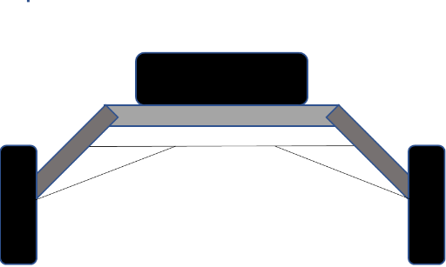

Figure 3: Concept 1

An idea spawned when benchmarking the Lunar Roving Vehicle (LRV) of the past. This concept consists of a four-legged rover chassis with wheels and an independent suspension system. To make this novel compared to the LRV, the suspension system is constructed so that each leg of the system can “hop” over uneven regolith at varied magnitudes. If this design used a dependent suspension system and traverses over a small crater on one side, the entire axel would rotate, creating an unfavorable bending moment around the chassis. The independent suspension postulated for this concept maintains the balance of the system through separating external loads from the main body and allowing the wheels to translate vertically through the z-axis. These characteristics would benefit the overall system by preventing total immobilization and providing escape mechanics. A disadvantage using this design is that the displacement of regolith after hopping is unknown, so there is uncertainty whether microscopic grains would negatively affect the system.

Medium Fidelity 2 - 4-legged system with scoop attachments
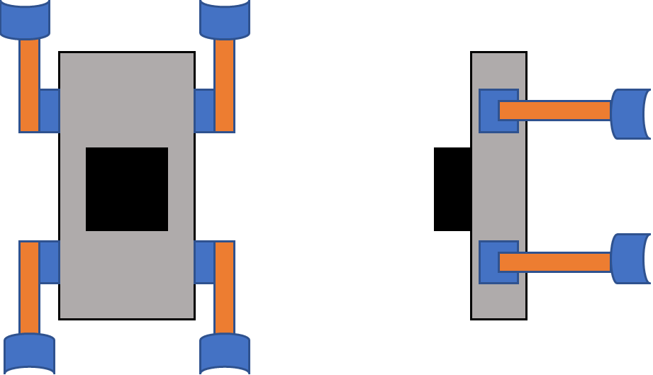

Figure 4: Concept 2

A legged system on the lunar surface will be a truly novel mechanism. That is because it has not occurred yet. Inspiration for the four-legged system with scoops stemmed from Dr. Clark’s research project. This was fructiferous as it contributes to a physical model that could potentially be picked. Angled correctly, the scoops could function as stable feet, paddles for swimming, or double as a crawling and climbing mechanism. This is ideal for irregular terrain as the exact topography mapping from satellites might be unknown. Dr. Clark’s design includes tines, which make these movements possible, but differs from this concept. The leg mechanisms would operate like Dr. Clark’s five-bar mechanism, which has been proven to function, but leads to high jerk values. This would be taken into consideration by the addition of a mass-spring-damper system to allow smooth travel. The black box in the sketch represents mounted LiDAR technology to guide the assembly through uneven terrain like craters on the surface and potentially lava tubes. The modifications made to conceptualize this design make it novel and limits the chance for immobilization.

Medium Fidelity 3 - Spider Design
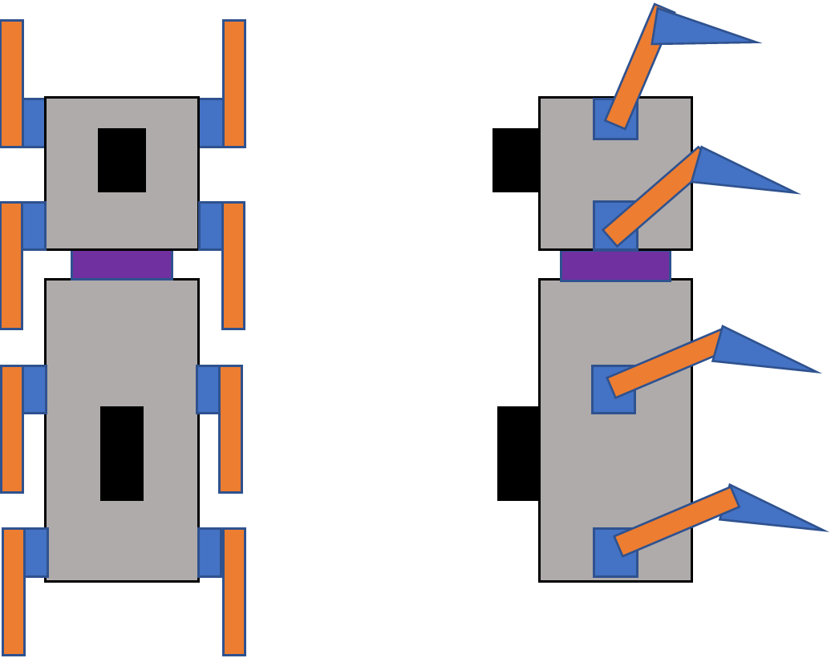

Figure 5: Concept 3

Biomimicry played a huge role in the conceptualization process. One of the suggestions was to imitate the dynamics of a spider. The leg mechanism utilizes the Jansen Linkage, which is explained further in High Fidelity 1. The structural makeup of this design consists of the main body with four externally protruding legs. The leg mechanisms are controlled by independent motors for varied torque and increased maneuverability. The foot of each leg is comparable to a snowshoe or a grid fin design to increase buoyancy on the surface, while simultaneously reducing the displacement of the regolith. The purple rectangle in the sketch represents an actuator that controls pitch, roll, and yaw of the system. This angles the head of the assembly in any preferred direction of travel. Like the body, the head also has four legs attached to maintain balance and prevent immobilization. The sensory equipment is identified by the black rectangles on the head and body.

Medium Fidelity 4 - Slithering Snake
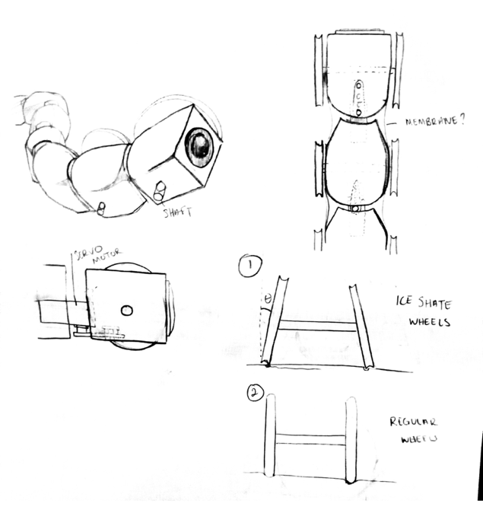
Figure 6: Concept 4

This design was conceptualized using biomimicry of a snake. The rover is broken up into multiple sections that are controlled by their own servo motor. Each individual section of the rover will have two, thin wheels that will propel the mechanism forward. The servo motors will allow the rover to achieve a slithering type of motion. The first servo motor would be set to turn at a given angle and the set angle given to each of the following servo motors will be delayed, providing continuous movement. This mechanism will allow the system to avoid obstacles on the lunar surface while also increasing the overall mobility through having a smaller turn radius.

Medium Fidelity 5- 4-legged rover with wheel attachments
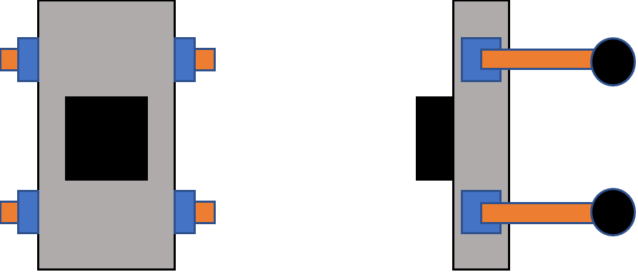
Figure 7: Concept 5

This design is based off the geometry of Dr. Clark’s robot. This concept is a good benchmark because it more closely resembles what is functioning on the Moon now. The four legs in this design act as rigid bars that hold the body of the rover higher above the wheel attachments. The wheels will have their own motors that dictate their individual speed. For this design, the legs have no degrees of freedom, and do not aid in the overall movement of the rover. The body of the system will hold all the technology and payloads. The black box represents the LiDAR mounted on top of the system.

1.5.2 High Fidelity Concepts

From the list of one hundred concepts, three designs were identified as high fidelity. These designs fit the customer’s requirements to the highest degree. During concept selection, one of these designs is most likely to be chosen as the final design for this project due to their practicality and high probability of success.

High Fidelity 1 - Jansen Mechanism Kinetic Linkage
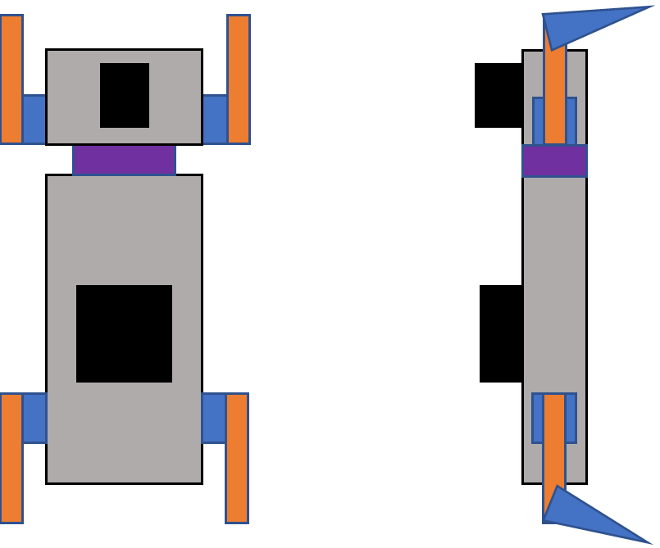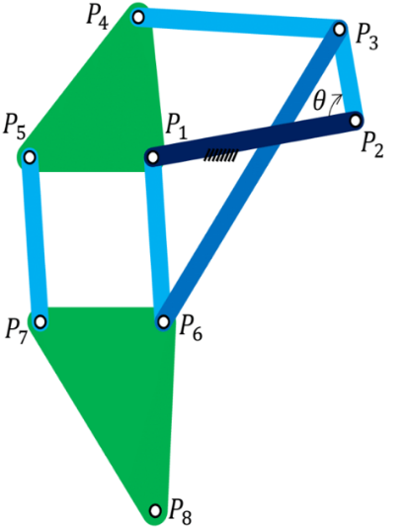

Figure 8: Concept 6
Inspiration for the development of this novel movement mechanism involved mimicry of art. For this high-fidelity concept, the vision is derived from Theo Jansen’s Strandbeest kinetic sculpture. The intention of this design is to incorporate a mathematically proven mechanism for consistent locomotion through regolith. The Strandbeest was constructed to be an exclusively mechanical structure where all the linkages are connected and depend on each other to move. To generate a novel mechanism, the idea is to implement four independent Jansen mechanisms, which mimic the dynamics of complex leg kinematics. The next addition is an actuator that connects the main body to the head of the system. This allows for control over pitch, roll, and yaw on irregular terrain.
The sketch of this design in Figure 8 includes a body with two legs protruding from either side, a head with two additional legs for support, a connecting actuator, and reserved space for sensory equipment. The Jansen Linkage itself has a crank link from points 𝑃2 to 𝑃3, which is in constant rotation through the duration of movement. The output from the mechanism is a resulting coupler curve that can be modified based on the link lengths. Research has been completed in this area, so it is possible to choose a predefined path and obtain the dimensions of each link. This design was chosen as a high-fidelity concept to possibly show how complex leg dynamics on Earth translate to the Moon.

High Fidelity 2 - 4-legged rover with snowshoe on bottom

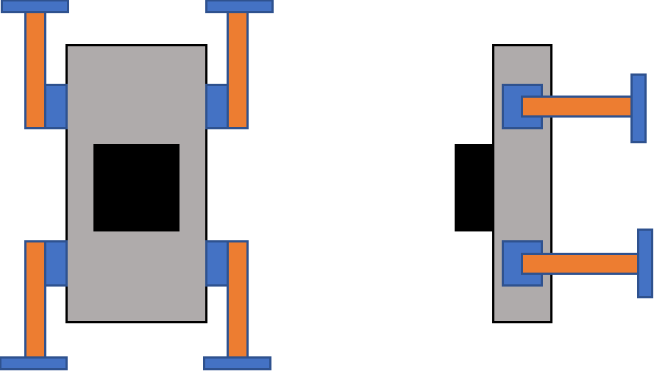
Figure 9: Concept 7
This concept was theorized from Dr. Clark’s current design and is similar to Medium Fidelity 2. The main difference being that the attachments on the feet of the legs are snowshoes instead of scoops or tines. The linkages will be constructed for predetermined coupler curves for each style of motion. This will maximize the efficiency for raising the feet off the regolith material and potentially for dragging the feet if submerged in shallow depths. The use of a snowshoe design, like Medium Fidelity 3, will have a larger area to distribute the force the system is exerting on the ground to minimize how deep the rover sinks into the regolith, and how much it will cause the regolith to displace. This was identified as a high-fidelity concept due to the relatively simpler integration of avionics into the entire assembly.

High Fidelity 3 - Office Chair Mimicry

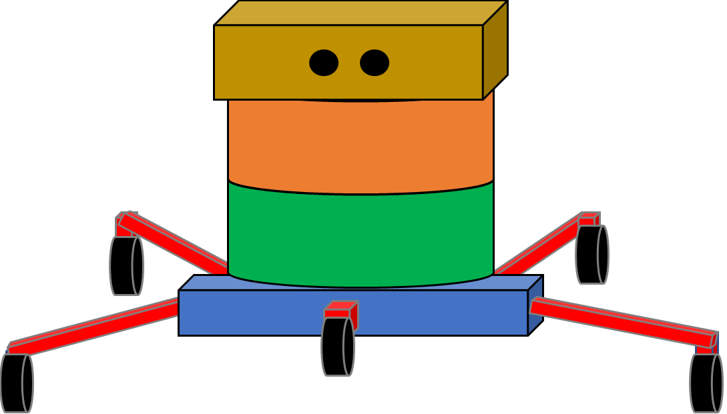

Figure 10: Concept 8

The inspiration behind this design was to model the appearance of the bottom part of a rolling office desk chair. This design is unique because none of the legs are attached to the side of the rover's body. The legs will all stem from a single bar that is centered underneath the rover. The body of the rover replicates a cylinder where the green section is the payload space, the orange section is where the technology, such as motors and sensory equipment, will be stored, and the yellow box includes the LiDAR system and other navigation optometry. The blue rigid bar will have five flexible arms attached to it. The flexibility helps the rover successfully travel across irregularities on the lunar surface. It also helps to eliminate how much the body will tilt. The undercarriage dynamics is governed by a suspension system to absorb impacts and control oscillations. The geometry and weight distribution of this concept will increase the overall stability and will maintain balance. Each leg extension will have an independent motor that controls its movement and speed. Certain joints will be used on each leg to capture two degrees of freedom where the legs will move vertically and horizontally. Wheels will be attached to each leg to traverse over the regolith.

1.5.3 What has Changed?
During concept generation, the scope of this project began to creep to fit time and budget constraints. Rather than focusing on the overall functionality of an entire robot, future design work will revolve around the linkages that make up the leg for a novel movement mechanism. The purpose of this is to concentrate on the objective and to not deviate away from the original intent of the project. The design of the base attachment will also be focused on as it is in direct contact with the lunar surface. The medium and high-fidelity concepts will still be used in concept selection because they all still have a different style and combinations of a leg and its base attachment.

1.6 Concept Selection

1.6.1 House of Quality
The House of Quality (HOQ) is a product planning matrix that is built to demonstrate how customer requirements relate directly to the customer's needs. Its main goal is to infuse the voice of the customer into the design process and to determine which engineering characteristics most closely relate to the customer requirements. The left side of the matrix contains the customer requirements, and their importance weight factors. The value of each weight factor for all the customer requirements was determined by using a binary pairwise comparison chart. In this chart, each of the customer's needs was compared against all of them to determine whether the customer need was more important (adding a “1”), or less important (adding a “0”). The results of this chart, as seen in Table 5, provide the important weight factors for each customer requirement, which is then included in the House of Quality.

Table 5: Binary Pairwise Comparison Chart
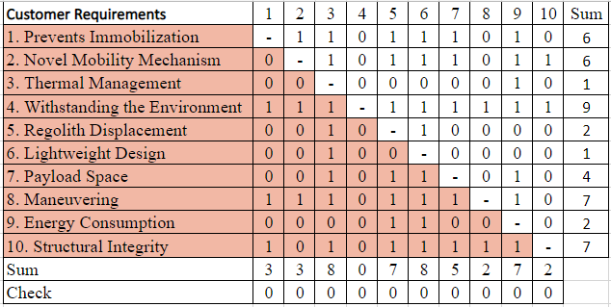

The engineering characteristics are listed by columns and are specified by its improvement direction and units in the metric system. Some engineering characteristics, such as maximum velocity and simplicity, have an increased impact on the final product since these are desired to reach a minimum target. For charging, it is desired to reduce the time and thus impacts the project less than more important characteristics. For tolerances, an oscillatory direction of improvement is ideal since the design can have small or large tolerance due to the interaction of regolith with the structure and hardware. A varied direction of improvement is also given to the structural thermal properties since some components are desired to have a small thermal conductivity, such as an insulator, whereas a heat sink for an electric component would have a large thermal conductivity to dissipate the heat more efficiently.
To determine which engineering characteristics are most important, a scale using values of 0, 1, 3, and 9 was used to analyze whether a particular engineering characteristic can satisfy the customer requirements. After populating all the numbers in the matrix, a raw score for each engineering characteristic was determined. Assigning the corrected weighted values, a relative weight value was computed. This resulted in an overall rank order for all the engineering characteristics. Table 6 shows the values given to each engineering characteristic when compared to a single customer requirement. The ranking order can be seen at the bottom of the matrix with Simplicity as the most important engineering characteristic and the Charging Time as the least important.

Table 6: House of Quality (HOQ)
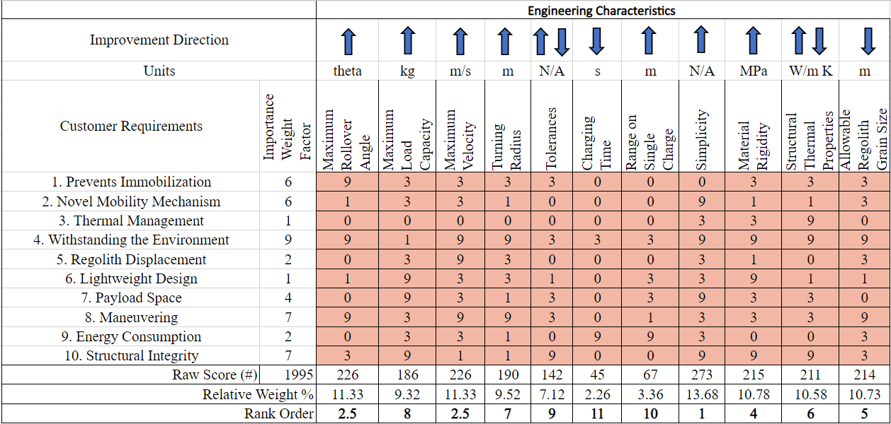

1.6.1 Pugh Charts
After determining the ranked order, the top seven engineering characteristics were included in the Pugh Chart. This chart is a tool that compares the medium and high-fidelity concepts to a certain datum. The Yutu 2, a robotic lunar rover from the China National Space Administration’s Chang’e 4 mission, was selected as the first datum. This rover was selected as the datum because it had the longest mission survival duration for a lunar rover, and it has several features that provide a fair elimination process to ultimately determine the best design. If a concept had a better way to meet the selected criteria as compared to the datum design, it received a plus sign (+) in the chart and a minus sign (-) if this was determined to be worse. An (S) was assigned in the chart if the datum and a concept had similar ways to accomplish the selected criteria. Table 7 shows the first iteration process with Yutu 2 as a datum and the number of pluses and minuses to evaluate which concepts will go to the next iteration process and which would be eliminated.

Table 7: Pugh Chart with Yutu 2 as a datum
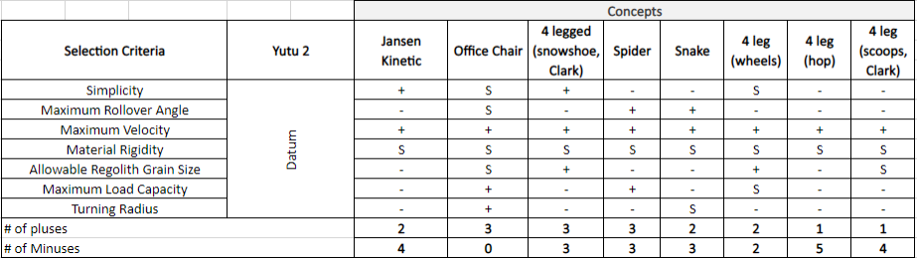

The results of the Pugh chart in Table 7 show that the concept with the most minuses was the four-legged hopping design, therefore it was eliminated. Since the Yutu 2 design was providing similar results to a few concepts, the Pugh chart in Table 8 uses the Spider as the new datum because it is one of the concepts that show an ideal ratio of pluses and minuses as seen in Table 7. This is beneficial since it can provide a fair comparison to determine the best result.

Table 8: Pugh Chart with Spider as a datum
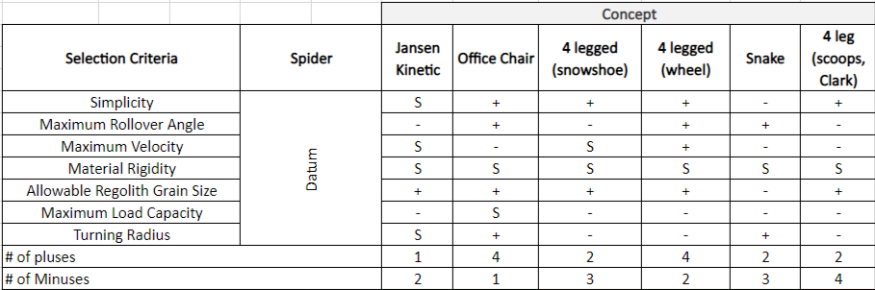

Changing the datum from the Yutu 2 to Spider yields the elimination of the four-legged with scoops concept. In order to ensure the three best designs were selected to move forward, another iteration of the Pugh chart was completed. In the third and last attempt, the datum was changed from Spider to the four-legged (wheel) and this last iteration process determined the three best concepts to be Jansen Kinetic, Office Chair, and four-legged with snowshoe designs. Table 9 shows the results of the last Pugh chart. The final three designs that were selected from the Pugh Charts were then used in the Analytical Hierarchy Process to decide which design will best fulfill most customer requirements.

Table 9: Pugh Chart with 4 legged (wheel) as a datum
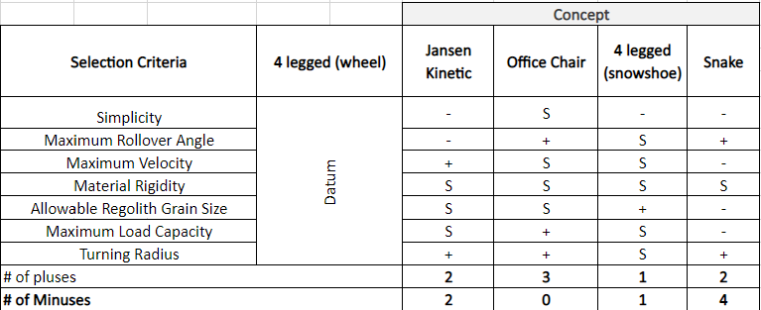

1.6.3 Analytical Hierarchy Process (AHP)
The AHP is a structured method for integrating the most important engineering characteristics of the design into the analysis of concept selection through quantitative and qualitative aspects. Following the House of Quality, the process for completing the Analytical Hierarchy Chart includes a Criteria Comparison Matrix, a Normalized Criteria Comparison Matrix, a Consistency Check Matrix, and directly comparing each concept to collectively decide on a final design selection. The Criteria Comparison Matrix explicitly compares the selection criteria against each other. The Normalized Criteria Comparison Matrix reveals the criteria weights to determine the most important criteria. The Consistency Check Matrix is derived from the elemental matrix division of the weighted sum factor by the criteria weights. The resultant values obtained are called consistency vectors. The average of the consistency vectors equals a lambda value. The concepts are compared against each other using the ranking system, then normalized using the criteria weight for each criterion. The values obtained are used in the final rating matrix, which outputs the highest ranked concept. These tables can all be seen in Appendix E.
Ranking for each selection criterion uses a 1-9 (odd numbers only) numerical system: 1 ranks both criteria of the same importance and 9 ranks a criterion strongly over the other. When one requirement is given a value, the opposing one will receive its reciprocal. After ranking the importance of each requirement, the sum of the columns results in a score for the characteristic. This sum shows which customer requirement is the most important to help the mechanism succeed. The Normalized Criteria Comparison Matrix takes the values of a specific customer requirement and divides it by its sum. Then, it adds all the divided values together to achieve a nominal output of 1. It also calculates the criteria weight by taking the average of all values of each row. This identifies which of the criteria are the most important to the mechanism.
Table 10 shows the Criteria Comparison Matrix. The selection criteria were compared against each other and an odd value from 1 to 9 was assigned for each comparison. The results given by this table are to be normalized. In Table 11 the criteria weights for the ranking of important selection criteria were determined. Maximum velocity had the highest criteria weight, followed by simplicity, structural thermal properties, material rigidity, turning radius, maximum rollover angle, and allowable regolith grain size.

Table 10: Criteria Comparison Matrix
 | Criteria Comparison Matrix [C]
 | Simplicity | Maximum Rollover Angle | Maximum Velocity | Material Rigidity | Allowable Regolith Grain Size | Structural Thermal Properties | Turning Radius
Simplicity | 1 | 5 | 0.33 | 3 | 7 | 3 | 3
Maximum Rollover Angle | 0.20 | 1 | 0.14 | 0.33 | 5 | 0.33 | 1
Maximum Velocity | 3.00 | 7.00 | 1 | 3 | 5 | 3 | 1
Material Rigidity | 0.33 | 3.00 | 0.33 | 1 | 5 | 1.00 | 3
Allowable Regolith Grain Size | 0.14 | 0.20 | 0.20 | 0.20 | 1 | 0.2 | 0.33
Structural Thermal Properties | 0.33 | 3.00 | 0.33 | 1.00 | 5.00 | 1 | 5
Turning Radius | 0.33 | 1.00 | 1.00 | 0.33 | 3.00 | 0.20 | 1
Sum | 5.34 | 20.20 | 3.34 | 8.87 | 31.00 | 8.73 | 14.33

Table 11: Criteria Comparison Matrix
 | Normalized Criteria Comparison Matrix [normC]
 | Simplicity | Maximum Rollover Angle | Maximum Velocity | Material Rigidity | Allowable Regolith Grain Size | Structural Thermal Properties | Turning Radius | Criteria Weights {W}
Simplicity | 0.19 | 0.25 | 0.10 | 0.34 | 0.23 | 0.34 | 0.21 | 0.24
Maximum Rollover Angle | 0.04 | 0.05 | 0.04 | 0.04 | 0.16 | 0.04 | 0.07 | 0.06
Maximum Velocity | 0.56 | 0.35 | 0.30 | 0.34 | 0.16 | 0.34 | 0.07 | 0.30
Material Rigidity | 0.06 | 0.15 | 0.10 | 0.11 | 0.16 | 0.11 | 0.21 | 0.13
Allowable Regolith Grain Size | 0.03 | 0.01 | 0.06 | 0.02 | 0.03 | 0.02 | 0.02 | 0.03
Structural Thermal Properties | 0.06 | 0.15 | 0.10 | 0.11 | 0.16 | 0.11 | 0.35 | 0.15
Turning Radius | 0.06 | 0.05 | 0.30 | 0.04 | 0.10 | 0.02 | 0.07 | 0.09
Sum | 1.00 | 1.00 | 1.00 | 1.00 | 1.00 | 1.00 | 1.00 | 1.00

1.6.4 Final Selection
After analyzing the results from the House of Quality, Pugh Charts, and AHP tables, a final design was selected. The finalized matrix was computed using the design alternatives method where concepts were evaluated on one criterion. Each criterion had its own tables where the final three concept ideas were compared to each other to determine which design was more successful at that individual criterion. The process for creating these tables and rating each design is the same as the AHP tables shown above. All individual tables can be seen in Appendix E. Once each criterion was evaluated, the finalized matrix was determined and can be seen below.

Table 12: Finalized Matrix
Concept | Alternative Value | Rank
4-legged rover (snowshoe) | 0.31 | 2
Jansen Kinetic Rover | 0.26 | 3
Office Chair Design | 0.42 | 1

Based on these results, the office chair design appears to be the best design. With these results, the sponsor and advisor of this project were notified of the final design choice so they could give feedback. After further discussion, it was concluded that while the office chair design fulfills the highest number of customer requirements, it would likely be one of the most difficult designs to build. Since the highest ranked customer requirement is simplicity, choosing the office chair design is not practical. The office chair design is complicated and may be too expensive to create under the given budget and time frame for this project. The sponsor and advisor of the project both agreed that the best design to continue this project would be the four-legged rover with a snowshoe-like attachment. Choosing this concept will allow the focus on this project to remain centered around creating and testing a novel mobility method for the lunar surface. Using this design concept will also allow access to utilize prior work, equipment, and testing apparatuses that Dr. Clark has used for his robot.
The selected design will be a four-legged rover that has a snowshoe like attachment on the bottom of the leg which is in direct contact with the lunar surface. The legs will be designed to follow a particular coupler curve to ensure the highest level of efficiency while crossing regolith. The use of snowshoe-like feet will minimize the negative effects regolith can have on the equipment by making sure the rover does not sink as far down in the regolith and making sure a minimal amount of regolith is displaced while the system operates. The design for this concept is pictured below in Figure 11.

Figure 11: Final Concept Selected

1.7 Spring Project Plan
The figure below shows the generated Project Plan for the Spring.
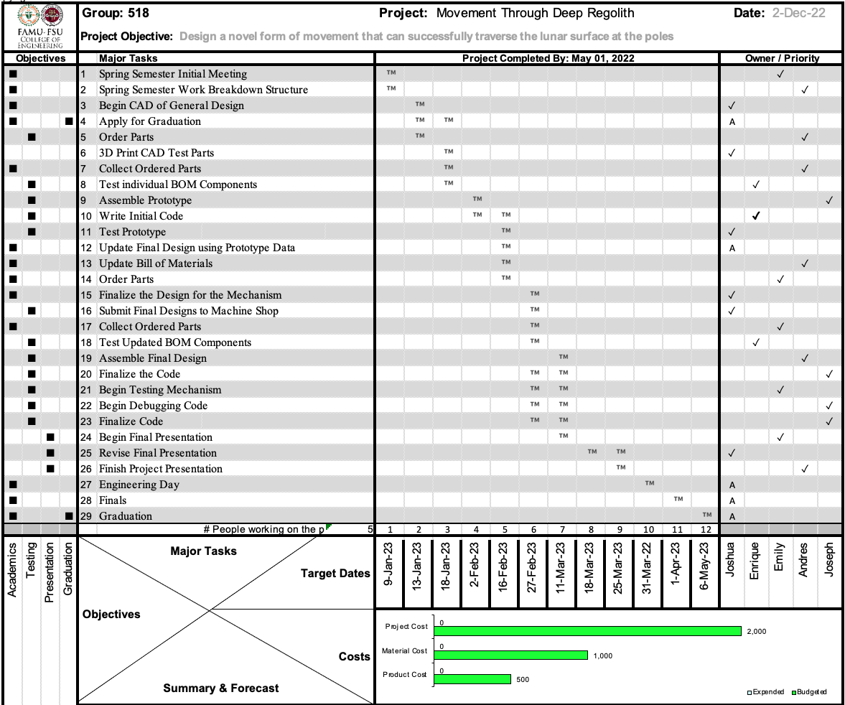
Figure 12: Spring Project Plan

Chapter Two: EML 4552C

2.1 Project Scope Restatement

2.1.1 Project Description
Our original objective was to develop a system that can successfully explore and maneuver through regolith in the lunar poles. But with the help of the CISCOR Lab, allowing us to use their robot (the ET-Quad), we narrowed down our scope to accommodate for the time and budget. Our new objective was to design a novel form of movement that can successfully traverse the lunar surface. This new design primarily focuses on the foot and ankle that will attach to the ET-Quad

2.1.2 Key Goals
The main goal of this project is to ensure that the system can get from one point to another without getting stuck. It is most important that this device can transverse the lunar surface. This project aims to be lightweight, limit regolith displacement, and resist the effect of regolith. It was important to keep the design lightweight for it to be cost-effective. The designs' ability to limit the displacement of regolith will help it prevent regolith build up on the system and making the design regolith resistant will help it preserve the designs’ life cycle.

2.2 Experimental Setups

2.2.1 Regolith Displacement Test Assembly
A drop test of a flat plate with different lattice designs was performed to determine which geometry would be most beneficial to Project Achilles. Area reduction per unit area consists of removing material at the center from a 25.4 mm x 25.4 mm square region. Figure 13 shows an example where 40% of the area is removed.
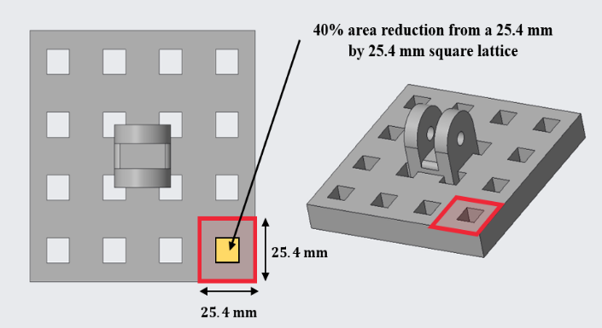
Figure 13: Foot sample with 40% area removed from unit square

The experiment consisted of dropping the flat plate at a fixed height into regolith simulant and measuring two important pieces of data: the penetration depth and the regolith plume profile. During the experiment, 25%, 40%, 50%, 60%, and 75% area reduction per unit area was used to analyze the response of the penetration depth and the plume generation as a function of the material subtraction.
The Regolith Displacement Test Assembly (RDTA) was created as the test rig to provide a consistent and controlled environment for such experiments in Earth-like conditions, which was a key assumption of the project. The test consisted of five different components. The first component is the container, a (254 x 254 x 254) mm acrylic box that stores regolith. The simulant used for the drop test was a simulant created by Team 518, called Regolith-Simulant (RS) 518. RS-518 is a good approximation for regolith simulant and its composition consisted of 55% dry sand, 35% baby powder, and 10% coarse coffee grounds. A support and guide keep the dropping device which is used to attach the foot sample and allows a smooth and perpendicular motion of the parts during the experiment. A dropping device, which is a two-piece arm that has the connects to the foot sample, allows the user to add additional mass to the system to maintain a constant mass during the experiment for all the samples.
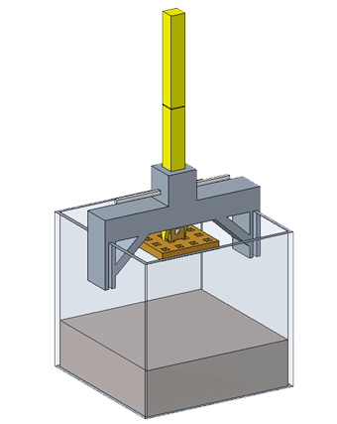
Figure 14: Assembled RDTA

The experimental procedure for the drop test was created to ensure consistency between trials. Figure 14 shows an assembled view of the RDTA. Since each foot sample had a different mass, the foot sample that weighed the most was used as a reference and counterweights were added to the dropping device for the foot samples that had a smaller mass. The intent was to have a similar mass of a foot sample with the dropping device to ensure the force due to gravity would be the same for every experiment. This allowed the only variable factor to be the pressure exerted at the bottom of the foot sample on the surface.
A camera with slow-motion settings was used to capture the regolith plume profile during the drop test. The camera was aligned so that it matches the front side of the regolith container. Some markers are created to make the measurement more consistent. Although it is not required, a camera or cell phone holder might provide more accurate measurements. The distance between the camera system and the regolith container is not fixed, it depends on various factors. However, the idea is that each measurement is consistent to allow better data analysis.
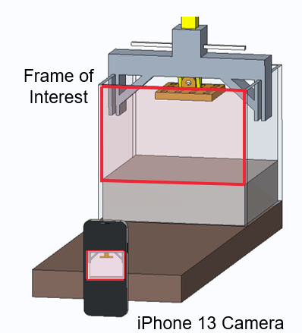
Figure 15: Data Acquisition for Plume Data

Figure 15 shows the data acquisition setup including a camera capturing the frame of interest. The recording started before releasing the pin for the drop test. For better results, a dark cover underneath the test assembly to the camera system was used. Light settings in the room where the experiment is taking place would vary a lot. It is important to have good diffuse illumination, not direct. The user that removed the release pin did not have their shadow present in the video recording.
Once the video was recorded, the frame when regolith was disturbed the most was selected. This was selected by looking at the settings of the video and taking a screenshot. Although it reduces the resolution, this minimized the time during post-experimental data processing. Other alternatives would be importing the video into editing software and selecting the exact time frame for more precision.
For the penetration depth, an initial measurement was taken before performing the set of experiments. This was done to have a reference value to determine the penetration depth of each test drop. The intent was to measure the distance from the lower part of the foot at the highest elevation to the surface of the regolith simulant. One user carefully moved the dropping device with the foot attachment towards the surface, without sinking it. At the top of the guide, the reference mark was placed on one side of the dropping device. After performing drop tests, a measured value mark was placed somewhere above the reference mark. This was because the dropping device with the foot will sink into the regolith simulant, displacing material around the sample.

2.2.2 Traction Test
The traction test was conducted at the Regolith Simulant Fields at NASA-MSFC. Background research emphasized the need for an increased level of traction due to the high amounts of slippage that can occur on the lunar surface. The Traction Test was used to determine the static and dynamic coefficients of friction. The static coefficient of friction, $μ_{s}$, is determined by the force required to make an object start moving when it begins at rest. The dynamic coefficient of friction, $μ_{k}$, is determined by the force required to keep an object moving along the surface at a steady pace.
Five different traction designs were tested: the Claw, Spikes, Angled Cleats, Hook and Rails, and Rowed Spikes. Each design was 3D-printed with a basin on top so mass could be added to each design. Each design was placed lightly on the regolith surface with 100 g mass added in the basin, then attached a force gauge, and pulled across the regolith surface. This experiment was completed six times for each design: three times to determine $μ_{s}$ and three times to determine $μ_{k}$. Figure 16 shows the Traction Test being performed at NASA-MSFC.
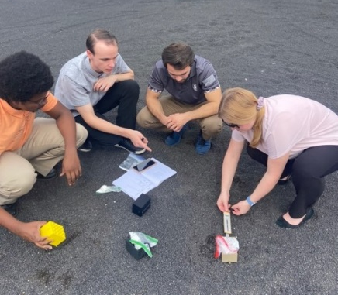
Figure 16: Team 518 Conduction the Traction Test at NASA-MSFC

2.2.3 Movement Test
Movement tests were conducted at the Center for Intelligent, Systems, Control, and Robotics (CISCOR) Lab at the FAMU-FSU College of Engineering. A Boom Test was used to experimentally verify the Achilles model. The apparatus consisted of a beam that was connected from a rotating motor to an individual leg mechanism on a circular track. This setup was able to perform hopping and walking gaits that replicated ET-Quad's movement. Figure 17 shows an example of the Boom Test. The computer in the picture was used to control the experiment and map new gaits.
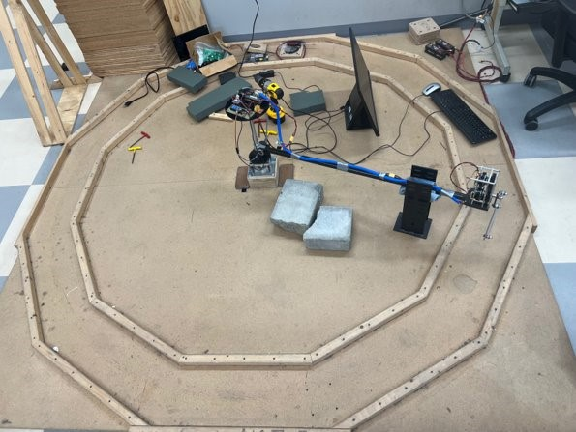
Figure 17: Boom Test Setup at the CISCOR Lab

Initially, a hopping gait was used to observe the compressibility of the Achilles model and to witness how the hardware performed in tandem with the leg mechanism. Figure 18 shows a demonstration of this equipment. This model mimics a one-dimensional Spring-Loaded Inverted Pendulum (SLIP) Model by bouncing the foot only in the vertical direction.
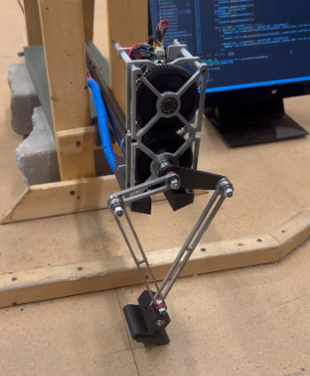
Figure 18: Experimental Setup for the Boom Test Utilizing a Hopping Gait

After the hopping gait, a walking gait test on flat ground was completed. Figure 19 shows an instance of this test. A flat surface allowed the observation of all the phases of walking, including stance, compression, and flight. It also gave a preview for how the Achilles model would behave integrated with ET-Quad.

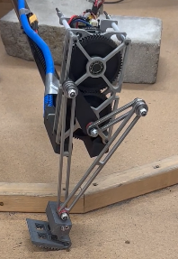
Figure 19: Boom Test for Walking Gait on Flat Ground

Following walking on flat ground, the Achilles model was subject to resistive media testing. Figure 20 presents the model crossing regolith simulant from NASA-MSFC. The granular terrain imitated the lunar surface by allowing the model to sink below the surface, thereby repelling the motion of the mechanism.
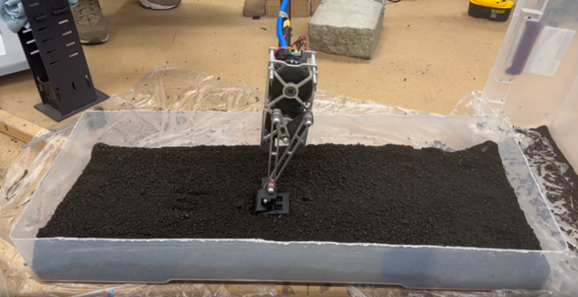
Figure 20: Boom Test Walking Gait on Regolith Simulant

2.3 Results and Discussion

2.3.1 Results from Drop Test
There are two main pieces of data gathered from the RDTA that helped to select the appropriate lattice size. The two key pieces of data are the regolith plume created and the penetration depth each design caused. Figure 21 shows an example image of the regolith plume that one of the designs created.

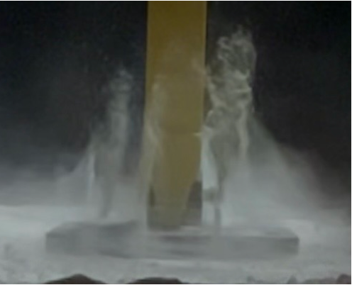
Figure 21: A Frame from RDTA Drop Test

Figure 22 shows the results of the plume percentage profile created by each foot in the RDTA.

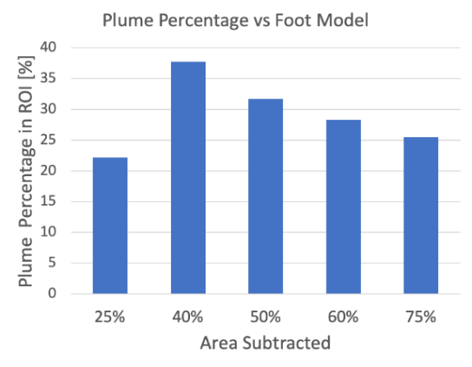
Figure 22: Plume Percentage vs. Area Subtracted from Foot Sample

While evaluating these results, it became apparent that the lattice design where 25% of the area was taken out did not follow the expected trends. After further investigation, the team determined the design with 25% of the area removed was printed on a different 3D printer and ended up having different density properties. This resulted in that design being treated as an outlier. The other four designs followed the expected trends and the team decided to focus on the lattice designs where 50%, 60%, and 75% of the area had been removed. Figure 23 shows the average penetration depth that each design caused.
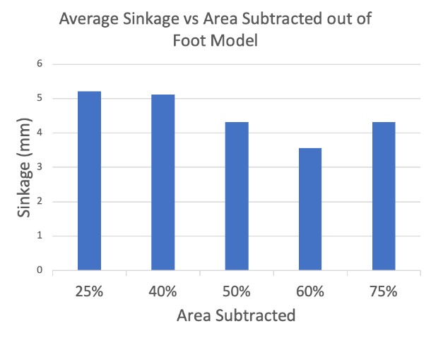
Figure 23: Penetration Depth vs. Area Subtracted from RDTA Results

The team expected to see the sinkage each design caused decrease as more area was taken out. Figure 23 shows the negative trend for most designs, but it became evident that the design with 75% of the area removed began to show higher penetration levels. To better understand these results and to determine what was happening during the test, the team decided to compare the mass of each individual foot with the penetration depth they caused.

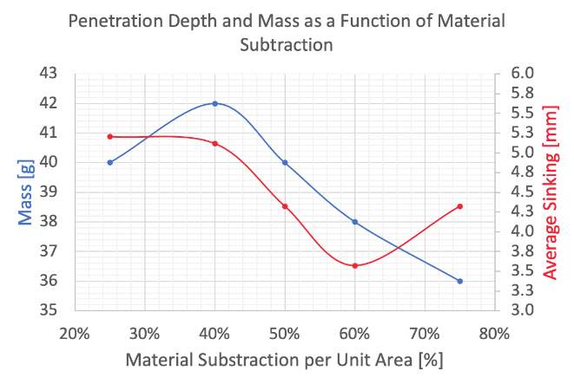
Figure 24: Mass and Sinking vs. Area Reduction

Figure 24 confirmed that an increase in area removed will decrease the foot's mass and the penetration depth it causes. This only starts to change between the 60% and 75% area reduction due to a penalty zone that was found. The team discovered that when the mass is decreased too much, the surface area of the foot decreases, which exerts a higher pressure on the surface. This minimized surface area and higher-pressure results in the foot design digging down and sinking deeper into the regolith surface.
The selection of the lattice design became a balancing act between the mass of the foot, the pressure the foot exerted on the surface, the regolith plume that was generated, and the penetration depth that each foot caused. After deliberation, the team decided the lattice design that achieved the best balance and would minimize regolith disturbance was the lattice design where 60% area reduction per unit area had been removed.
To verify the usefulness of the lattice feature, the 60% area redacted design was directly compared to a solid flat plate that had no area removed. The average sinkage for the flat plate was 4.16 mm while the 60% area reduction design presented an average sinkage of 3.57 mm. The plume percentage profile could not be calculated due to the intensity of the regolith plume that the flat plate caused. The flat plate was the only design that caused such an intense plume where simulant escaped the testing apparatus. This validated that a lattice design was an important aspect of the final design. After these trials, the team continued with the lattice design that had 60% of the area removed.

2.3.2 Results from Traction Test
The best traction design will be the one that produces the highest coefficients of friction. The force of friction, $F_{f}$, was experimentally found from the force gauge reading. The normal force, N, was calculated by summing the mass of the traction samples with the additional mass. These measurements were taken in grams and were converted to Newtons. The coefficient of static, $μ_{s}$, and dynamic friction, $μ_{k}$, were found from equation (1) by dividing $F_{f}$ by N.
$F_{f}=μN$ (1)

After the traction test and calculations were completed, the results were calculated and compiled into Figure 25.
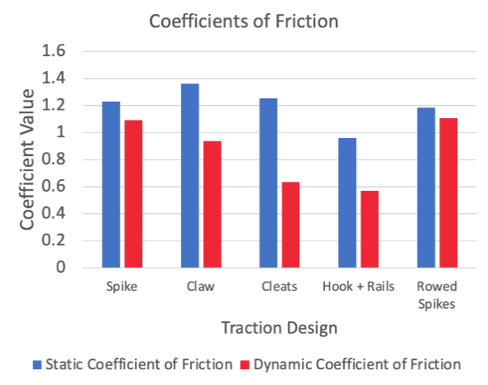
Figure 25: Coefficients of Friction vs. Traction Design

The Cleat and the Hook and Rails design were immediately eliminated as a traction choice since they presented the smallest dynamic coefficients of friction. The next design determined to be least practical was the Claw design. To generate friction coefficient values that high, the size and radius of the Claws curve had to be increased to such a large amount that it became impractical to integrate that traction design onto a foot. After the analysis, the two final designs to be chosen from were the Spikes and Rowed Spikes design. Figure 26 shows the two final designs. The Spikes design is on the left, and the Rowed Spikes can be seen on the right.
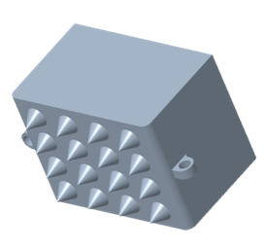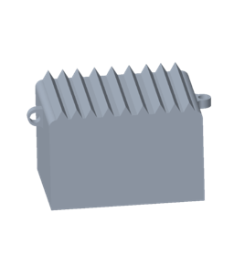
Figure 26: The Spiked and Rowed Spike Traction Designs

These two designs had nearly equivalent coefficients of friction. The Spiked design presented a higher static coefficient of friction while the Rowed Spikes presented a higher dynamic coefficient of friction. To decide what design would be best, the team moved on to manufacturing both designs via 3D-printing and integrating each design with the 60% area lattice. The Spiked design had issues fitting into the small spaces of material left in the lattice design, while the Rowed Spike design easily fit into any configuration of the lattice. The main deciding point between these two was the ability to manufacture and produce each design. Through rapid prototyping, it was determined that the Spiked design could not be easily printed. There were multiple failed prints involving the Spiked design, while the Rowed Spikes always presented clean and accurate prints. This was the main deciding factor for selecting Rowed Spikes to be the best overall traction design.

2.3.3 Results from Movement Test
The results of the Boom Test verify the combination of the lattice design, traction feature, and compliant structure. The hopping gait confirmed the strength and compressibility of the material. No failure occurred throughout the hopping test or the walking gait phase of the movement tests. Qualitatively, the Achilles model showed minimal plume through the lattice, no slippage because of the traction feature, and satisfactory compressibility during resistive media testing. The CISCOR ET-Quad claw stomped through the regolith, which caused large penetration depths, dispersed simulant omnidirectionally, and clogged the individual tines. Various gait maps were created to customize the experience for both models. The gait itself had to be mapped with a larger retraction such that the models could be lifted out of the regolith simulant. Figure 27 shows the curve that the leg mechanism was following throughout the movement tests. Seven points of reference were used to draw a spline for the gait.
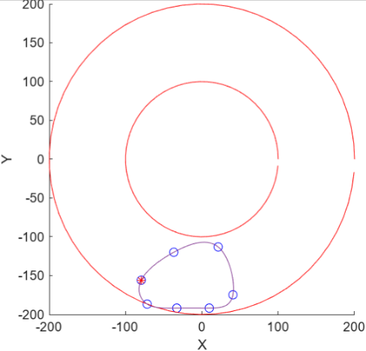
Figure 27: Larger Retraction Gait Map

Throughout each of the trials for the Boom Test, quantitative data was collected. The main data observed was the Torque on the motors vs. Time, as seen in Figure 28. The minimum in the graph coincides with the compression of the model across the stance phase of walking. As the curve increases to a positive value, the model is in flight, then the maxima shows when the foot lands on the simulant. The signs represent the direction of forces. The noise between each of the phases is from the kickback of the model and oscillatory vibrations sent through the mechanism to the motor sensor. This data was important for verification because it shows a stable steady-state convergence over time with minimal deviations from the peaks. It also showed that the motors were not being overworked.

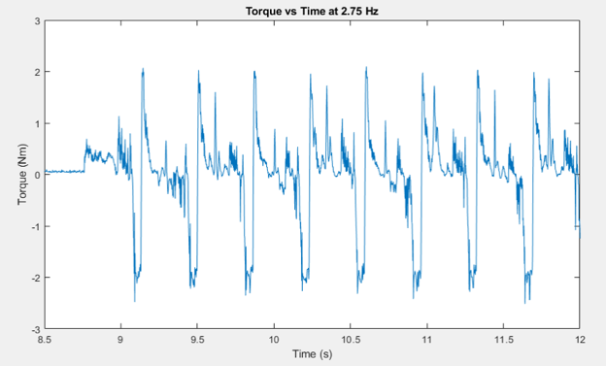
Figure 28: Torque vs. Time Data for a Walking Gait at 2.75 HZ

The Boom movement tests were critical for determining the success of the Achilles model. During the walking gait test, a lot of regolith simulant was scooped and kicked forward because of the flat top surface. This contrasted with the ET-Quad claw, which sent the simulant in multiple directions. This resulted in optimization to be conducted on the design of the Achilles model. The geometry changed to have a wider base that decreased the pressure on the surface and a curve was created on the front to prevent regolith from being picked up. This was confirmed from additional movement tests by witnessing the locomotion. During compression, simulant reached the top of the arc, but did not fall on the inside of the curve. The regolith that was kicked forward occurred because of the traction design on the bottom. This occurrence could be fixed by retracting the leg mechanism even further within the gait map. The optimization successfully decreased the penetration depth further and minimized the displacement of simulant. Overall, success was found by witnessing no failure, observing the phases of walking, and predicting how the model would be integrated with ET-Quad in the future by moving through deep regolith simulant.

Conclusion
Due to failed lunar expeditions from regolith and its properties, it is important to investigate alternative ways to traverse the lunar surface. Team 518 focused on working with those at the CISCOR lab to determine if a quadrupedal robot with certain foot attachments could successfully traverse deep regolith. The Achilles design focused on 4 key aspects: the lattice, the traction, the compression, and the integration with ET-Quad. Through testing individual components and analyzing the results, decisions were made to allow the Achilles model the best chance at walking through regolith. Through movement tests, such as the Boom Test, the combination of each component and the integration with ET-Quad was verified. The final Achilles model, shown in Figure 29, weighed 47 g, had dimensions of 60 x 76 x 50 mm, and has shown that it was our best option to successfully traverse the lunar surface by limiting regolith interference.
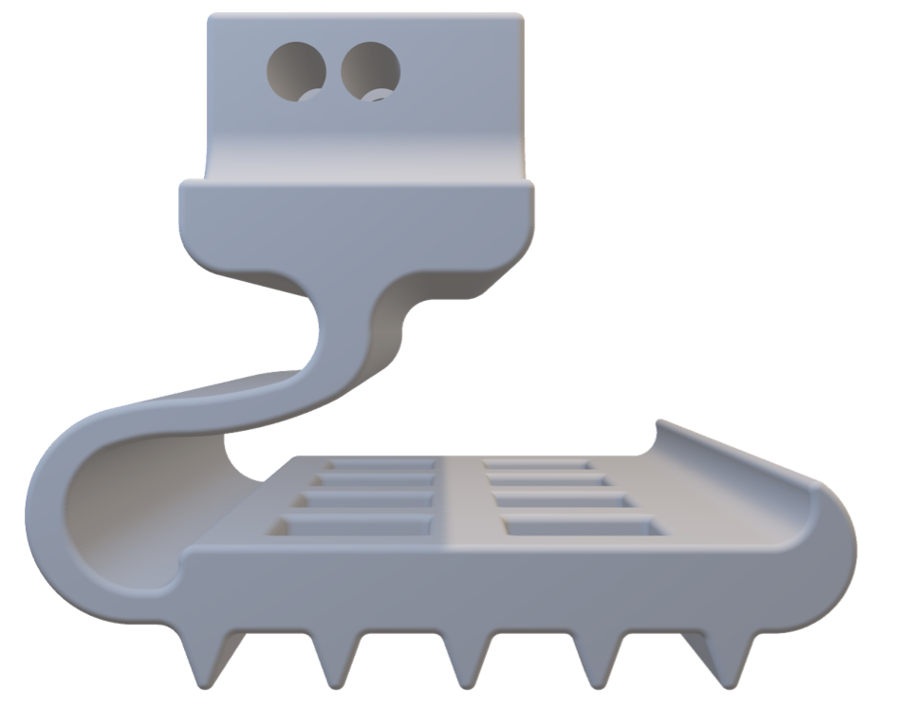
Figure 29: Final Achilles Model

Future Work

After all the testing has been completed, more work needs to be done to improve the final Achilles model. This includes continuing optimization of the geometry to minimize regolith kicking and working with the CISCOR lab to create more of a cam and follower curved gait path. The material had great compliance for what was needed, but more compressibility could be needed so that the model has a greater bend on the surface of regolith, rather than pushing down into the soil. Another improvement would be to have a tighter tolerance for the hardware. 3D printing the model led to inconsistencies with the tolerances such that some walls had shrunk or created larger holes. This sometimes made the model not have proper contact with the ground by having small moments at the ankle. Appropriately manufacturing this model with machining techniques could solve this issue. Fabricating a space grade version would consist of creating a thinner neck to have better compliance with the use of metallic materials.

References
Mo, John P.T. (2014). Engineering System Acquisition and Support, Woodhead Publishing Series in Mechanical Engineering, Elsevier, p.55

Appendix A: Code of Conduct

Mission Statement
The NASA-MSFC – Lunar Surface Project 2 Team aims to conduct all work throughout the year professionally and respectfully towards other team members, sponsors, and advisors. Every member will remain involved in the project and responsible for putting in hard work and effort into each task. Members will not only keep themselves accountable for their work but help to keep teammates accountable for theirs. Each member is part of this team and will do their best to create a positive work environment to ensure the team works effectively and productively.

Team Roles and Obligations
Every member will be responsible for looking over documents and adding their input when needed. All team members are aware that these roles are subject to change and be slightly altered once the project description is given and more specifics are known.

System Integration Engineer - Andres Hernandez Chapa
The System Integration Engineer is responsible for the development, testing, and validation of subsystem controls and for using fundamental principles in engineering sciences and a system thinking approach to understand the dynamic relationship among subsystems in the final design of the product. Outside obligations include literature reading on relevant topics for the project, collaborating in the design process with design engineers and ensuring that every team member documents any additions or changes to any component or process.

Project and Test Engineer - Emily Dawson
The Project Engineer focuses on making the project and team operate efficiently. The project engineer will help to manage time, delegate tasks amongst the team, have a final look over of all deliverables, and be the lead point of communication with sponsors and advisors. The test engineer will work closely with the design engineers and system integration engineer to ensure the product is high quality and functional. The test engineer will design testing conditions for each part of the device to ensure they work properly and determine if an aspect of the device needs to be altered to achieve better results.

Quality and Design Engineer - Joshua Baldwin
The Quality Engineer will focus on overseeing each portion of the project and will implement high quality standards. Checks will be performed throughout the process to ensure quality assurance is of the highest excellence. As a Design Engineer, CAD designs will be constructed to reflect the needs of the time. FEA analysis will be conducted as required to show structural integrity. Parts will be modeled, checked, and prototyped to maintain a consistent flow of analysis. Doubling as a Quality and Design Engineer, the roles will blend together to balance our workflow and will help produce our final product.

Software and Design Engineer - Joseph Way
The Software Engineer's role is to work on the program or code for the system or mechanism of the project if needed. It is their job to create an easy to read, fast, and functioning code. The software engineer will create code and test its functionality as frequently as possible to ensure quality performance and efficiency from the code. As a Design Engineer, sketches of the design will be made and, as a team, be looked over and redesigned if needed. These initial designs will then be made into CAD designs to fit the design at that point in time.

Manufacturing and Design Engineer - Enrique Chocron
The Manufacturing Engineer will focus on the design, development, and operation of integrated systems. The Manufacturing Engineer is also responsible for developing solutions to production issues and performing cost-benefit analyses. As a Design Engineer, 3D software will be used to design and produce parts and systems for the project, along with the other Design Engineers and the rest of the team.

Communication
Between team members, communication will primarily take place over GroupMe or Email. GroupMe will be used for more casual topics between groupmates, whereas email will be used for more professional and important discussions. Each team member should respond or acknowledge they have seen and read the message within 24 hours. Professional emails will be sent to communicate with the sponsor and advisor of this project.

Meetings and Attendance Policies
Team meetings will occur on Monday and Wednesday from 7:30 PM - 8:30 PM. Each member is expected to be present in all meetings and during class on Tuesdays and Thursdays. If necessary, a meeting can take place on Saturday afternoon if the team deems it. Weekly or bi-monthly meetings with our sponsor and advisor will be decided later once the team has received their project information. If a team member is planning on missing a meeting, they need to notify the group at least 24 hours before the start of the meeting. All members acknowledge meeting times may change depending on members work schedule and sponsor availability.

Dress Code
The dress code for the group will vary depending on the situation. For regular team meetings, members may wear casual clothing. Meeting with the sponsor and advisor will require business casual clothing. All group presentations require members to be in business professional attire.

Resolving Issues
If an issue occurs between group mates, the issue will first try to be resolved by the team. Team members may bring up an issue at a team meeting in a respectful and professional manner. The team will work to find a compromise and resolve the issue. If after one week the issue is still unresolved and nothing has changed, a team member may reach out to Dr. McConomy. We ask for Dr. McConomy to give insight or outside tips on how to resolve the issue. If after the two weeks the issue has still not been resolved, and most of the team agrees, Dr. McConomy can also provide a slight grade penalty to the individual.

Document Amendments
If a group member has a suggestion on how to change or amend this document, he or she may bring it up at a team meeting. The team will vote if they are in favor of the amendment or not, and if a majority is in favor, this document may be amended.

Statement of Understanding
By signing this document, the members of NASA-MSFC – Lunar Surface 2 (Team 518) agree to all the above and will abide by this code of conduct as set forth by the group.

Joshua Baldwin 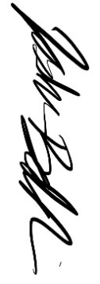 09/09/2022
Enrique Chocron 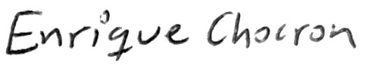 09/09/2022
Emily Dawson 09/09/2022
Andres Hernandez Chapa 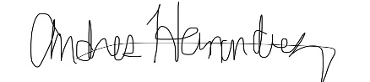 09/09/2022
Joseph Way 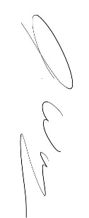 09/09/2022

Appendix B: Functional Decomposition

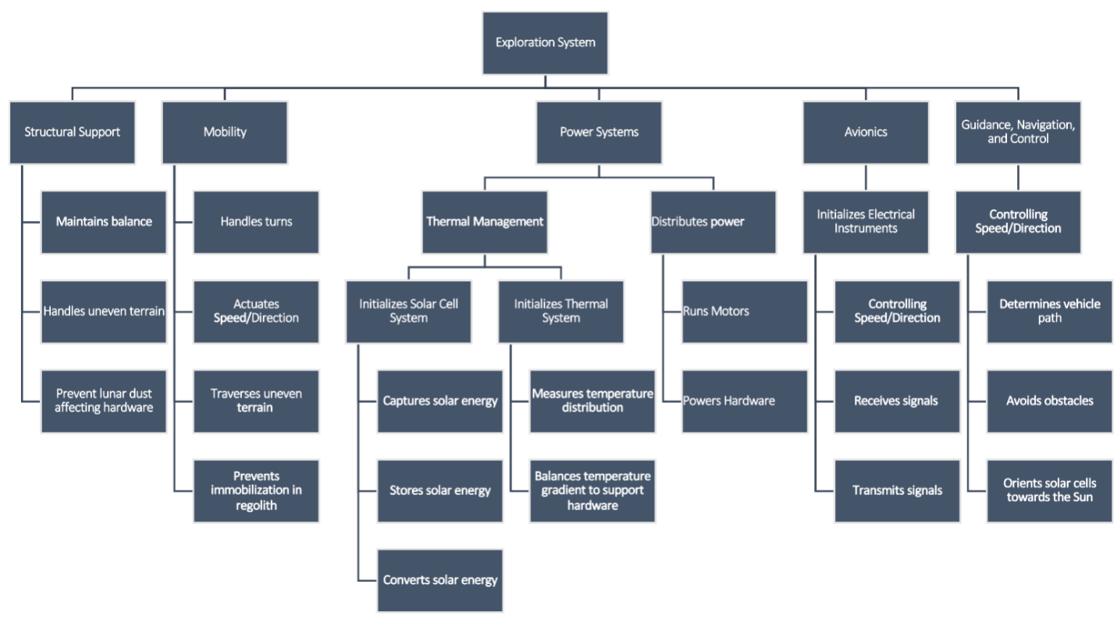
Figure 30: Functional Decomposition chart

Table 13: Functional Decomposition table
 | Function Class
 | Structural Support | Mobility Mechanism | Thermal Management | Power System | Avionics | GN&C
Controls Speed |  | X |  |  | X | X
Controls Direction |  | X |  |  | X | X
Handles turns | X | X |  |  | X | X
Maintains balance | X | X |  |  | X
Handles uneven terrain | X | X
Captures solar energy |  |  | X | X
Stores solar energy |  |  | X | X
Converts solar energy |  |  | X | X
Measures temperature distribution | X |  | X |  | X
Balances temperature gradient to support hardware | X |  | X | X | X
Receives signals |  |  |  |  | X
Transmits signals |  |  |  |  | X
Determines vehicle selenographic coordinates |  |  |  |  | X | X
Orients solar cells towards the Sun |  | X | X | X | X
Prevents immobilization in regolith | X | X |  |  |  | X
Prevents lunar dust affecting hardware | X
Distribute power |  |  |  | X
Avoids obstacles |  | X |  |  |  | X

Figure 31: Functions flowchart

Appendix C: Target Catalog
*All measured values are < 10% uncertainty

Table 14: Target catalog (lunar surface)
Functions | Function being quantified | Targets
Controls Speed* | Velocity resolution of the system | 0.001$\frac{m}{s}$
Controls Pitch* | Pitch resolution | 0.005°
Controls Roll* | Roll resolution | 0.003°
Controls Yaw* | Yaw resolution | 0.005°
Handles Turns* | Centripetal acceleration resolution | 0.001g$\frac{m}{s^{2}}$
Maintains Balance | Maximum rollover angle | 30°
Captures Energy | Minimum energy transfer efficiency | 70%
Measures Temperature Distribution* | Temperature resolution taken from various locations | 0.002 K
Balances Temperature Gradient to Support Hardware* | ∆𝑇 resolution from nominal values | 0.002 K
Houses Technology | Maximum volumetric space to hold equipment including sensors, actuators, wiring, etc. | $$1 m^{3}$$
Determines Lander Coordinates* | Upon deployment on the lunar surface, the system will use the lander as the origin for determining coordinates | 30’
Prevents Immobilization in Regolith | Instantaneous velocity error | >10% error of intended velocity
Prevents Lunar Dust from Affecting Hardware | Maximum allowable grain size | 10 𝜇m
Distributes Power | Energy given to each power system | <5% distribution error
Avoids Obstacles | Appropriate sensor, LiDAR, Ex: Ouster OS1 | Range of 90 m, 45° FOV
Communicates to Ground | Photography from the system | 1 FPS
(Theoretical – Lunar surface)

Table 15: Target catalog (Earth conditions)
Functions | Function being quantified | Targets
Controls Speed* | Velocity resolution of the system | 0.001$\frac{m}{s}$
Controls Pitch* | Pitch resolution | 0.005°
Controls Roll* | Roll resolution | 0.003°
Controls Yaw* | Yaw resolution | 0.005°
Handles Turns* | Centripetal acceleration resolution | 0.001g $\frac{m}{s^{2}}$
Maintains Balance | Maximum rollover angle | 30°
Measures Temperature Distribution* | Temperature resolution taken from various locations | 0.002 K
Houses Technology | Maximum volumetric space to hold equipment including sensors, actuators, wiring, etc. | $$1 m^{3}$$
Prevents Immobilization in Regolith | Instantaneous velocity error | >10% error of intended velocity
Prevents Lunar Dust from Affecting Hardware | Maximum allowable grain size | 10 𝜇m
Distributes Power | Energy given to each power system | <5% distribution error
Avoids Obstacles | User input resolution from controller | 8-bits

(Actual – Earth)

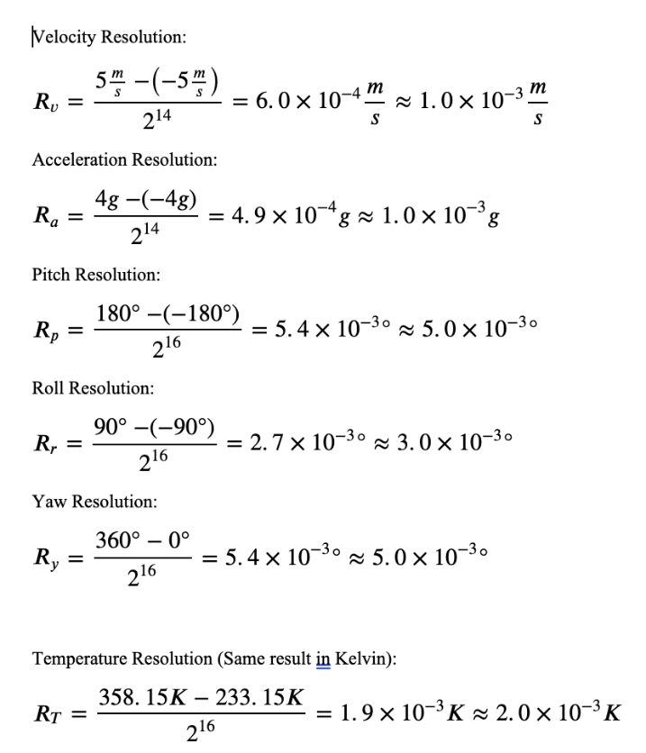
Figure 32: Function calculations

Appendix D: 100 Concept Ideas
- Wireless charging Jansen Kinetic legs
- Solar powered Jansen Kinetic Legs
- Wheels with teeth (escape wheel)
- Solar powered 4-legged rover with wheels
- Solar powered 4-legged rover with scoops
- Solar powered 4- legged with snowshoes on bottom
- Solar powered 4-legged rover with oars
- Solar powered 4-legged rover with lotus leaf grating
- Solar powered 4-legged rover
- Spider design (8-legged)
- Ant design (6-legged)
- Cockroach design (6-legged)
- Turtle design (Breaststroke Motion)
- Electromagnetically charged legs to repel regolith
- Boat
- Rover with Ice skates
- Penguin design (Waddles and slides)
- Rover with cold thrusters and track
- Continuous Track (Like a tank)
- Photon sail
- Rover with extremely large low-pressure tires (seal skin)
- Hybrid- 2 legs in the front, two wheels in the back
- Hybrid- 4 wheels, with legs that will drop when rover gets stuck
- Bipedal rover
- Solar powered Archimedes screw
- Wireless charging Archimedes screw
- Frog design (4- legged, hopping)
- Kangaroo Rover (Bipedal, hopping)
- 4-Wheel rover with assisting arm
- Wireless charging 4-legged rover with wheels
- Wireless charging 4-legged rover with scoops
- Wireless charging 4- legged with snowshoes on bottom
- Wireless charging 4-legged rover with oars
- Wireless charging 4-legged rover with lotus leaf grating
- Wireless charging 4-legged rover
- Tracks
- Slithering snake
- Centipede
- Wheels with cleats (like mars rover)
- Wheels with grousers
- Radioisotope thermal electric generator power source
- 2 wheeled rovers (scooter like)
- Super elastic Tires (airless, nickel titanium)
- Snowmobile (Tracks and skis)
- Jet ski
- Pogo stick (hopping type movement)
- Hoverboard one wheel movement
- Square shaped wheel (shark wheel for reference)
- Triangle shaped wheel
- Crab like design- 4 legs on each side of the rover and 2 arms
- Hybrid: regular front legs, 2 back legs with snowshoe or something with more surface area (think crawling)
- 4-legged rover with suspension to hop over regolith boulders
- Nitrogen thrust propulsion with skis (land rocket)
- Dolphin biomimicry – oscillating “swimming” movement above and below surface
- Dolphin biomimicry – upright system using a fin below the surface to propel
- Seal sliding translational movement
- Water strider bug (low surface tension mimicry)
- Basilisk lizard - “they run so quick that air pockets (voids in our case?) form under feet”
- 2 legs with multiple wheels attached (roller blading type movement)
- Western grebes – rapid bipedal paddling on surface
- Fishing spiders – waxy, “waterproof coating”
- Water snail – attaches itself upside down to surface of water by trapping air bubbles inside shell
- Lobster design- wheels or legs in front, flipper or something at back to propel forward when needed
- Office chair design- 1 central rigid bar below the body of the rover with 6 flexible legs attached that have wheels on the bottom- or other connections
- Solar powered office chair design
- Unicycle
- Bicycle
- Tricycle
- A novel lunar rover
- Omnidirectional, Mecanum Wheel (omni wheels)
- Slingshot propulsion
- Ion thrust propulsion
- Rover with Helium cold gas thrusters
- Spherical wheels
- Giant sphere with precise motion control
- Slinky walking spring
- Propulsion cube
- Burrowing rover
- Boring rover
- Prancing
- Wall-E
- Dynamic Quadruped
- Snail-like locomotion
- Desert Sand Snake motion
- Dragging mechanism
- Ostrich-like Bipedal Mechanism
- Wheels with no groove (Death Trap)
- A rover that paddles/displaces regolith to move forward
- Octopus design- 8 legs stem from under the rover
- Solar powered 2 bodied rover connected by a neck with 8 wheels
- A rover that has two large wheels, the wheels would be in the front and back and almost the width of the rover
- Worm design
- 4-legged with a six-bar linkage for legs
- 6-legged with four-bar linkages
- 6-legged with spherical wheels
- Giant rolling ball
- Humanoid Robot
- Paddle boat design
- Rover with 4 Paddle wheels
100. Horse design (4 legs with hoofs at the end)

Appendix E: Concept Selection AHP Charts
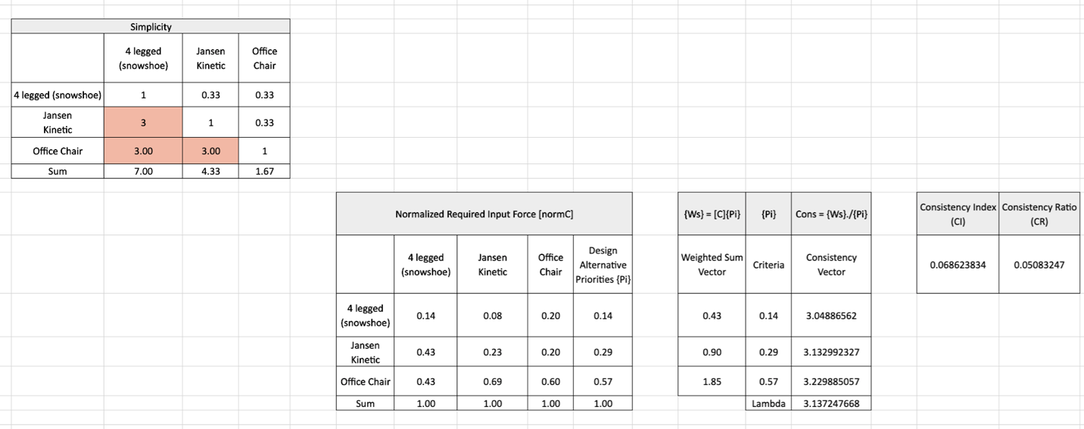
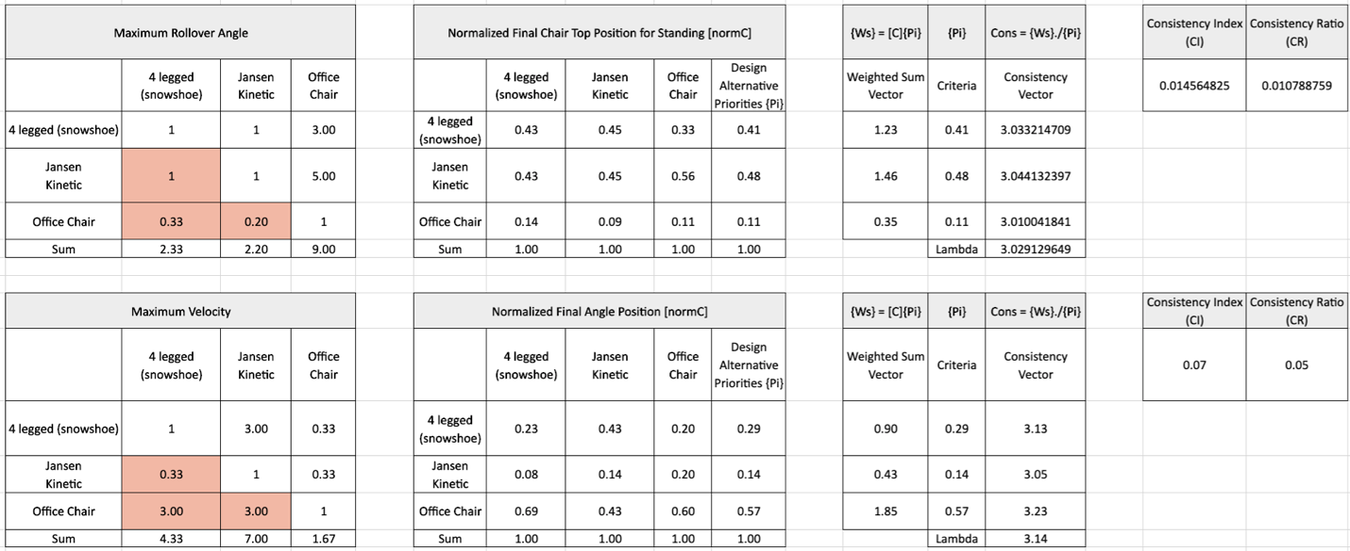
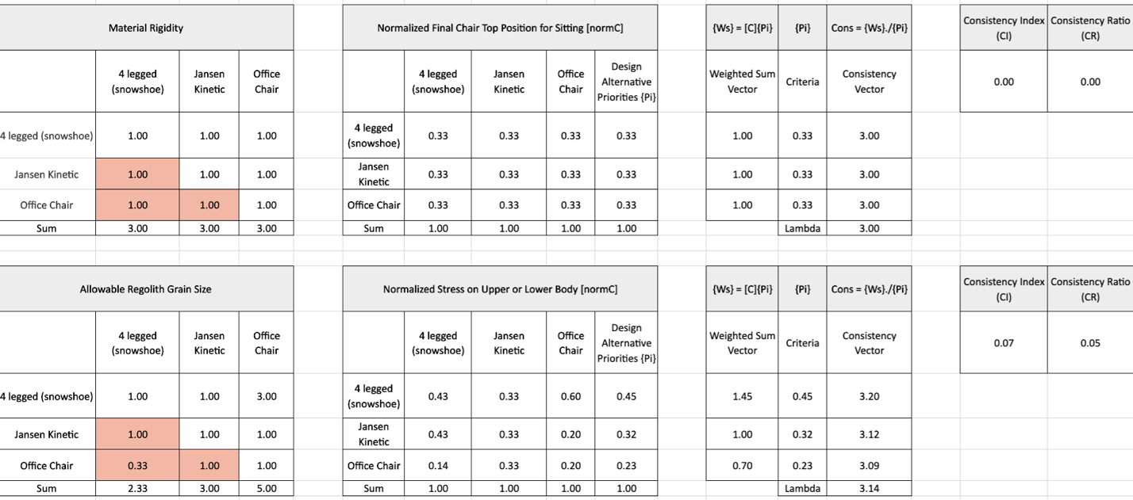
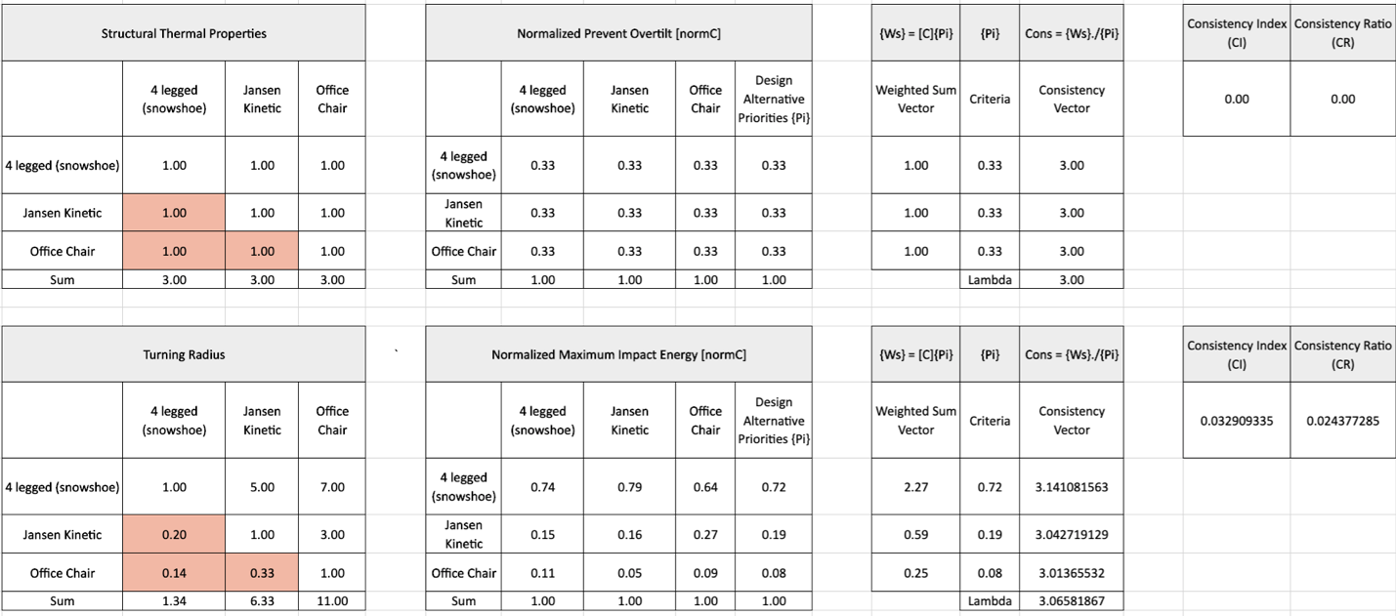
Figure 33: AHP Charts

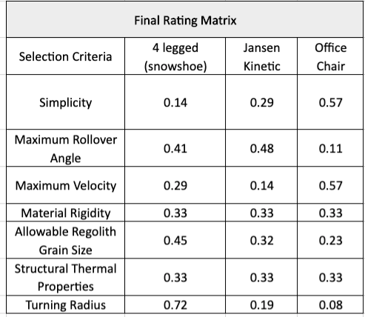
Figure 34: Final rating matrix

Appendix F: Operations Manual

Appendix F.1– Project Overview

F.1.1 – Project Description
Equipment on the Moon struggles with traversing lunar regolith, as the grains are very fine. This creates difficulty achieving good traction and affects hardware. Our team has partnered with NASA-MSFC to design and develop an alternative form of movement to traverse the lunar surface that maximizes traction and minimizes regolith displacement. This will be accomplished by designing a foot-attachment, nicknamed Achilles, which can be attached to quadrupedal robots. We have designed a prototype for testing to validate design choices, and to be recommended for use by NASA-MSFC and other space agencies.

Figure 35: Proposed Design

F.1.2 – Project Overview
The objective of this project is to design a novel form of movement to traverse the lunar surface.

F.1.3 – Key Goals
The key goals of the project are for the system to be lightweight, regolith resistant, and to increase mobility for quadrupedal systems.
The reason for choosing to be lightweight is because of two main reasons. First, it was determined that with a lighter foot, the system displaces less regolith due to reduced pressure on the surface, which minimizes possible damage to the system. Second, delivery costs of equipment to the moon are extremely expensive. Each additional pound represents about one million dollars, so the lighter the design, the less expensive it is to send to the Moon.
To achieve successful mobility, this design will be integrated with ET-Quad, a quadrupedal robot developed by our academic advisor. Mobility will be measured by the traction forces induced and the efficiency after integration. Some portions of the Moon present large areas of deep regolith or steep slopes. A design with poor traction is likely to get stuck and become immobile. It is important to include traction features on the foot-attachment to ensure good mobility and a high amount of grip to reduce slip.
Regolith resistance is important for the success of any system traveling to the Moon. Regolith is formed by meteorites, which causes its composition to be fine and sharp. Even with minimizing the displacement to protect the rover, the foot-attachment will be in contact with regolith throughout the duration of its use. That makes it imperative to have a design that can limit the negative effects of regolith.

F.1.4 – Assumptions
Some assumptions were made to narrow the scope of the project. It is assumed that the testing of the design will be conducted under Earth conditions. Since the Moon is surrounded by vacuum, it is nearly impossible to simulate lunar conditions on Earth. It is also assumed that Achilles will not be expected to maneuver anything steeper than a 30° incline. Additionally, thermal management will not be a concern for this project design. Lastly, it is assumed that the design will be attached to a functioning quadrupedal rover capable of locomotion across uneven terrain.

Appendix F.2 – Regolith Simulant
This project focuses on minimizing lunar regolith displacement and disturbance. It is important to have an accurate simulant of testing. Lunar regolith contains particles that are smaller than 10 $μm$in diameter up to a size that resembles boulders. Regolith is also known to be very sharp and jagged. If it is not possible to acquire actual lunar regolith simulant, a variation can be made with simple house-hold items. Regolith Simulant 518 was made from baby powder, sand, and coffee grounds. The mixture consists of 55% sand, 10% coffee grounds, and 35% baby powder. It is important to ensure that the sand is dry and does not hold any extra moisture. To ensure this, the sand should be baked at 450°F for 10 minutes, or until completely dry. Figure 36 shows a photo of this simulant.
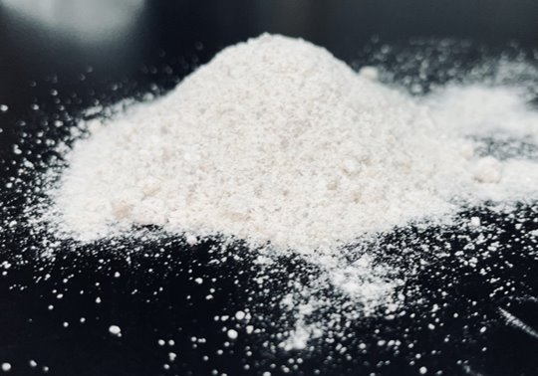
Figure 36: Regolith Simulant 518

Appendix F.3 – Penetration Depth and Plume Profile Detection

F.3.1 – Overview
This section shows detailed procedures on how to reproduce a drop test to determine penetration depth and plume profile from regolith simulant for various lattice designs. The goal of this experiment is to optimize structural features, minimize regolith plume disturbance, and sinking upon contact of the feet with a granular medium. A foot platform with different reductions in area will be used to test such parameters. At the end of this document, the reader shall be able to select a final design and integrate it with ET-Quad. The two experiments are performed in a controlled environment called Regolith Displacement Test Assembly (RDTA). The first part of this section explains how to reproduce and assemble the testing rig. It also presents the required tools for the experiment and how to set up the data acquisition components to measure the penetration depth and the plume profile.
The experiment consists of introducing a regolith simulant in the RDTA and then performing various drop tests with different lattice structures to measure the penetration depth and the plume profile generated. The frame of the video with the highest disturbance of regolith is converted as a binary image to determine the fraction of regolith plume present in a region of interest (ROI), which is defined by Team 518. A MATLAB program capable of these calculations and will be explained in more detail in this document. Finally, the numerical values are expected to be analyzed carefully to then start an optimization process with a selected lattice design. (Note: At least two members must be present during the experiments).

F.3.2 – Prerequisites
To create the Regolith Displacement Test Assembly (RDTA), computer-aided design software is required (e.g., CREO Parametric, AutoCAD, SolidWorks, CATIA V5). The following are some basic and minimum computer configurations that would provide sufficient performance for creating the parts of the test-rig and would also be sufficient to handle the post-experimental data collection, which requires Photoshop (or similar) and MATLAB.
- CPU Basic: 2.5 GHz – 2.9 GHz processor
- RAM Basic: 8 GB RAM
- Conventional Display: Full HD display (1920 x 1080)
- GPU Basic: 1 GB GPU
For the acquisition of the plume profile, a video camera with a slow-motion feature from a cellphone or camera is required. Since the particles move quite quickly, a slow-motion video can capture plume disturbance with higher precision. In between experiments, it is expected to have a mixing device such as a whisk to remove any compacted regions of regolith simulant. This would make experiments more consistent.
This experiment also requires a mass scale to measure the mass of the various foot designs, some washers or nuts with known mass, a ruler or vernier caliper to measure penetration depth or amount of regolith simulant in the container and an Excel sheet to measure all the data recorded.

F.3.3 – Regolith Displacement Test Assembly
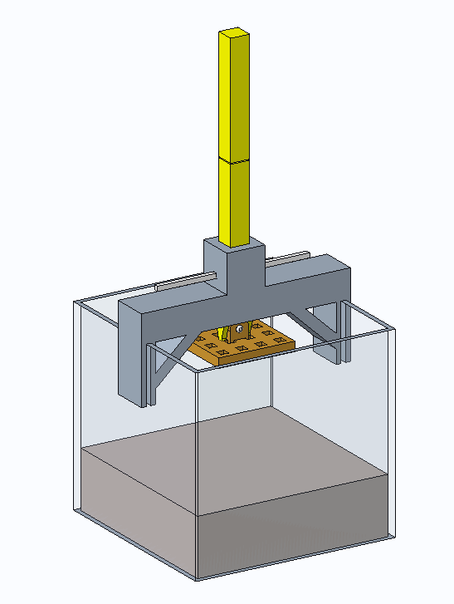
Figure 37: Regolith Displacement Test CAD Assembly

The Regolith Displacement Test Assembly (RDTA) is a controlled and consistent environment for analyzing penetration depth and regolith plume disturbance. It consists of the following components:

- [REGOLITH CONTAINER]: (10 x 10 x 10) inch acrylic box that stores the simulant.
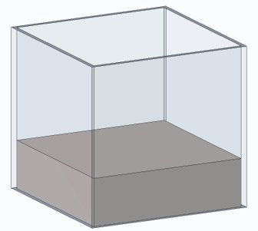
Figure 38: Regolith Container
- [SUPPORT]: Two-piece support structure that easily attaches to [REGOLITH CONTAINER].
Figure 39: Support Piece

- [GUIDE]: Single piece component that is attached to the two pieces of the [SUPPORT]. It keeps the [DROPPING DEVICE] in place and holds the [RELEASE PIN]. This component allows the possibility for the [DROPPING DEVICE] to fall perpendicularly every time.
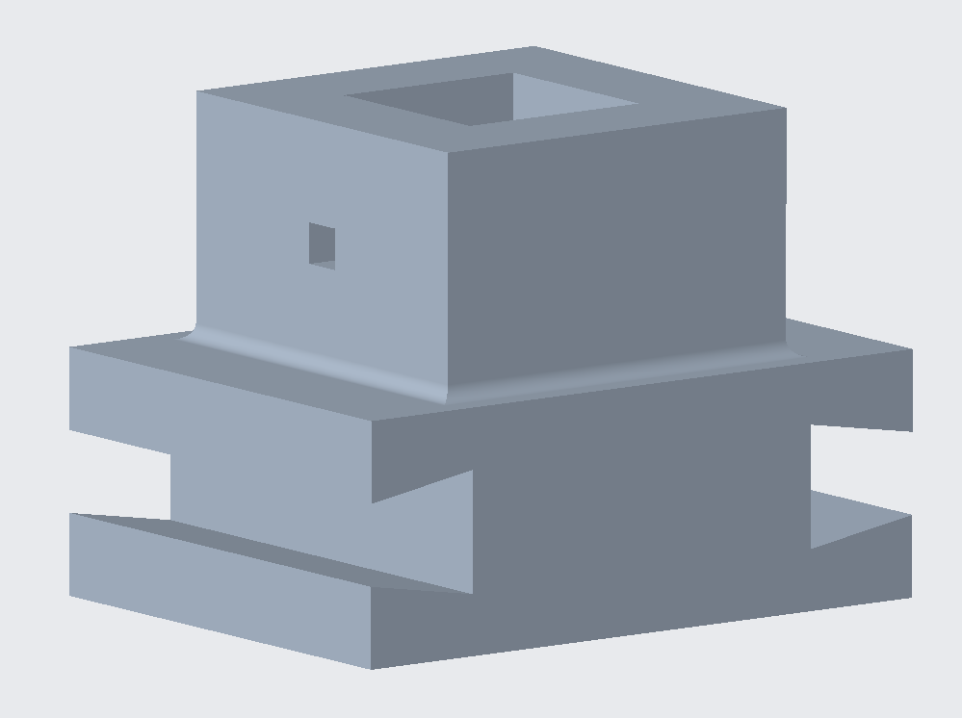
Figure 40: Guide
- [DROPPING DEVICE]: Two-piece dropping arm that includes a release hole for the [RELEASE PIN] and a foot connection end, in which various foot lattice designs can be attached. This component permits the opportunity to have a modular test assembly.
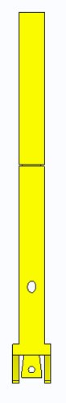
Figure 41: Dropping Device

- [RELEASE PIN]: Extended pin used to release [DROPPING DEVICE] from the test assembly.
- [REGOLITH SIMULANT]: See Section 2 – Regolith Simulant.

F.3.4 – Regolith Displacement Test Assembly: Test Assembly
One part of the [SUPPORT] is attached to the [GUIDE] at one end, while the other part of the [SUPPORT] is attached to the other end. The three pieces are then inserted into two wall sides of the [REGOLITH CONTAINER]. The two parts of the [DROPPING DEVICE] are connected and should make the dropping arm have a distance of [X]. Finally, the foot design used in the experiment is attached to the lower part of the [DROPPING DEVICE], which has the foot connector feature. The ends are connected with a ½” clevis pin with 1” length.

F.3.5 – Experimental Procedure

The following numbered list shows the steps used during the experiment.
- Calculate foot mass: all the feet masses are calculated using a mass scale and recorded.
- Add extra weight in the form of washers to the shaft on top of the dropping device if needed: the heaviest foot is used as a reference and the other feet should match the same weight. This is done to ensure that the force exerted to the surface with regolith simulant is always the same one to reduce the number of variables in the data analysis section.
- Attach foot to [DROPPING DEVICE]: the foot design used in the experiment is attached to the lower end of the [DROPPING DEVICE] with the clevis pin.
- Insert [DROPPING DEVICE] to [GUIDE]
- Prepare data acquisition system (See Section 2.6.1 and 2.6.2 for more information).
- Begin video recording. (See Section 2.6.1)
- Remove [RELEASE PIN].
- End video recording after 10 seconds.
- To mark measured value on the [DROPPING DEVICE], mark the place where the top of the [GUIDE] levels or touches the [DROPPING DEVICE].
- Reset the [DROPPING DEVICE] so the foot is suspended in air.
- Next, lightly mix and level the surface of the regolith.
- Repeat steps 4-11 so that each foot has five data points gathered.
- Detach the foot and take the [DROPPING DEVICE] out of the [GUIDE] to allow for easier measurement collection.
- Measure each of the five penetration depths and record values. (See Section 2.6.2)
- Deeply mix and stir the Regolith with a whisk. Make sure to reach the bottom corners and edges. Ensure the regolith is level at the end.
- Repeat steps 1-15 for each foot available.

F.3.6 – Data Acquisition for RDTA
A camera with slow-motion settings is used to capture the regolith plume profile during the drop test. The camera is aligned so that it matches the front side of the regolith container. Some markers are created to make the measurement more consistent. Although it is not required, a camera or cell phone holder might provide more accurate measurements. The distance between the camera system and the regolith container is not fixed, it depends on various factors. However, the idea is that each measurement is consistent to allow better data analysis. The Figure 42 shows how to align the camera system to the markers in the regolith container.
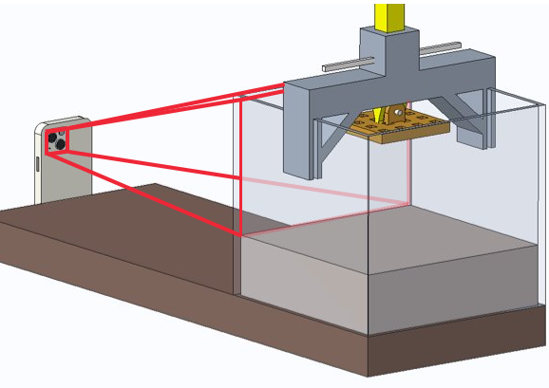
Figure 42: RDTA Data Acquisition Set-Up
The red lines show what the camera is supposed to capture. The user needs to determine the appropriate distance from the camera to the marks in the container. The recording should start before releasing the pin for the drop test. For better results, a dark cover underneath the test assembly to the camera system, without interfering with the video is recommended. Light settings in the room where the experiment is taking place would vary a lot. It is important to have good diffuse illumination, not direct. Also, the user that removes the release pin should be located at a place in which their shadow is not present in the video recording.
Once the video is recorded, the frame when regolith is disturbed the most is selected. This can be selected by looking at the settings of the video and making a screenshot of it. Although it reduces the resolution, this minimizes time during post-experimental data processing. Other alternatives would be importing the video into editing software and selecting the exact time frame for more precision.
For the penetration depth, an initial measurement is taken before performing the set of experiments. This is done to have a reference value to determine the penetration depth of each test drop. The intent is to measure the distance from the lower part of the foot at the highest elevation to the surface of the regolith simulant. One user should carefully move the [DROPPING DEVICE] with the foot attachment towards the surface, without sinking it. At the top of the guide, the reference mark is placed on one side of the [DROPPING DEVICE]. After performing drop tests, a measured value mark is placed somewhere above the reference mark. This is because the [DROPPING DEVICE] with the foot will sink into the regolith simulant. Figure 9 shows the two marks on the arm.
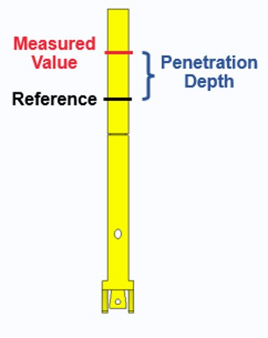
Figure 43: Dropping Device with Measurements
The black line is the reference mark while the red line is the measured value. The difference between the two is the penetration depth. The measured values should be erased each time the foot is replaced. It is recommended to use a pencil to do this and that the [DROPPING DEVICE] is printed in a color such as yellow.
Once the penetration depth is measured with a ruler or caliper, it is recorded for data analysis. Five drops are performed for each lattice design. Then calculate the average penetration depth. The data is compared among the other designs with a plot of penetration depth (sinking) against area subtraction.

F.3.7 – Post-Experimental Data Processing
A template is created in Adobe Photoshop to align all the frames. It consists of three blue boxes. The two at the top are used to align the dropping device in the middle while the bottom one is used to match the lower portion of the foot. Figure 44 shows an example of how it is supposed to look.
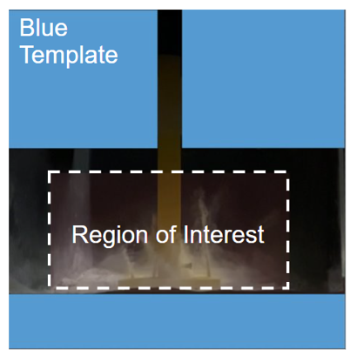
Figure 44: RDTA Template Set-Up

A top layer is also created to carefully analyze a small portion of the picture. This is the Region of Interest (ROI), which is a transparent-red rectangle that will be used to produce a binary image and will facilitate the determination of regolith distribution for each drop test. The following portion of this section shows a way to determine how to trace the plume profile.
Since the regolith simulant consists of small particles, a Plume Profile Identifier (PPI) needs to be created. This is a technique used to determine the profile generated for all the tests with consistency. It is based on a comparison of the transparency level of the clearest regolith particle to the black background of the regolith container. The idea was inspired by fog measurements. The visibility level and confidence level values are created to compare the plume layers. The figure below shows an example of the PPI curve with its respective confidence level curves.
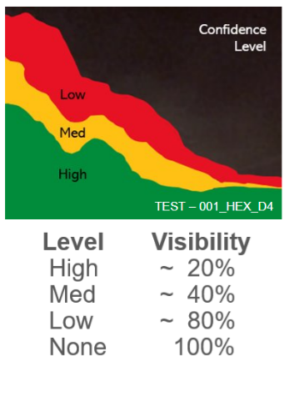
Figure 45: Regolith Plume Confidence Levels

The green region implies a high level of confidence that regolith simulant is captured in the video and is set to a value of approximately 20% visibility against the background. The yellow region is set to a medium level with 40% and the red, a low confidence level, is set to 80% or higher. The PPI is selected between the high level and the medium level to facilitate the process.

With the use of a raster graphics editor such as Adobe Photoshop, create the PPI image. Import the image into the program and perform the following sequence.
- Import selected image into Adobe Photoshop.
- Convert image into a Smart Object.
- Import <BLUE_TEMPLATE.PNG>.
- Import <ROI.PNG>.
- Select selected image from drop test.
- Select Polygonal Lasso Tool and start selecting points using the PPI technique.
- Hold Ctrl while left clicking to select multiple points in the image. Be sure to include the dropping arm and the foot, which appears inside the region of interest (ROI).
- When finished, press right click and select “Layer Via Copy”.
- Select the copied image at the right panel with all the layers, right click and select “Blending Options".
- Select the box "Color Overlay".
- Set color of overlay, located in the “Blend Mode” section.
- Select white using the “Color Picker”.
- Save the layered copy as a .PNG file.
- Create a new file using (Ctrl+N) with the following dimensions:
  - Width: 800 pixels
  - Height: 400 pixels
  - Resolution: 72 pixels/inch
  - Color mode: Grayscale (8 bit)
  - Background Content: Black

- Import .PNG file that was used to trace the plume profile.
- Go to “File” > “Export” > “Export As” > “File Setting”.
- Set .JPG
- Set “Quality” to [2].
- Export
Import the black and white image that was created from Section F.7.3 into the MATLAB program called: <REGOLITH_PLUME_PROFILE_IDENTIFIER.m>. (Note: be sure to have the MATLAB program and all the images in the same folder). In MATLAB, go to “Editor” and hit “Run”. The program will prompt the user to select an image file. It will automatically read the image file and convert it to grayscale for better results and into a binary image file, an array of zeroes and ones. A “1” denotes the pixels that are white while “0” the pixels that are black. The program counts the total number of pixels by multiplying row size by column size of the imported image. To determine the number of white pixels, all the ones are added up. Two variables will be stored, one for the total number of pixels of the overall image and another for the white pixels only and a ratio is computed. This ratio is the percentage of white pixels in the image, which is the amount of regolith present in the region of interest. The process is repeated for all the other files. The code is attached at the end of this document (See Appendix B: Code).

F.3.8 – Troubleshooting for RDTA
If the [DROPPING DEVICE] does not follow a smooth path through the [GUIDE], adding some tape to the four inner walls of the [GUIDE] will minimize the friction between the two parts. It is recommended to clean the front wall of the RDTA to make better recordings of the experiments. If the side walls are covered with plumes from previous experiments, it is recommended to clean them with a dry towel. Having particles attached to the walls can cause some interference when selecting the plume profile.
A possible error that can occur with <REGOLITH_PLUME_PROFILE_IDENTIFIER.m> is that the program could fail to compute the ratio between white pixels to total pixels. To prevent this, it is recommended to save the black and white image in Adobe Photoshop as a .JPG, and not as a .PNG file. Another possible mistake is to save the file in the opposite way, meaning that the plume profile is set to black while the background is set to white. This will produce an error in the ratio. A solution to this is by inverting the image colors with the following line of code:
inverseGrayImage = uint8(255) – grayImage;

Appendix F.4 – Traction Test
This section details the procedure and materials for replicating the traction test used to analyze various proposed designs. The intent of the traction test is to determine the best extrusion for the bottom of the foot attachment. The best extrusion will be decided by which design can provide the highest coefficients of static and dynamic friction. The test pieces were brought to the NASA-MSFC regolith simulant field for testing, but similar composite soils can be used for approximate results.

F.4.1 – Parts and Components
The components of the traction test consist of:
- Model test pieces
- A force gauge.
- An added mass
- Regolith simulant
The test pieces are designed as an open container with hooks on both sides out of phase by 90° for optimal attachment of the gauge. The bottom of the model, shown in Figure 46, possesses the intended traction design for evaluation. Detailed drawings of each tested model can be found in the appendix. An Ohaus force gauge was used with a scale ranging from zero to two-hundred-fifty-grams. The added mass can be any object or substance that can fit inside of the container. For the experiment, baking soda was put into a zip-loc bag and measured at one-hundred-grams. This provided the necessary values for the force gauge scale. The regolith can be homemade (See Section 2) or high-fidelity volcanic gravel as the NASA-MSFC simulant.
Figure 46: Example Traction Design

F.4.2 – Experimental Procedure
The coefficients of dynamic and static friction are the key data parameters for the traction test. Data acquisition will consist of obtaining the force of friction and subsequently calculating the coefficients of friction. Experimentation should have at least three trials each.

F.4.3 – Static Coefficient of Friction
- Set a test piece on the surface of the simulant.
- Place a one-hundred-gram weight on the inside of the container portion.
- Attach the force gauge to one of the hooks.
- Pull very slowly until the piece breaks into motion.
- The highest force reading is the force of friction.
- Record this value for each trial.

F.4.4 – Dynamic Coefficient of Friction
- Repeat the process from Section 4.3.1, except pulling the test piece continuously over a length of twelve inches.
- Record the average force reading for each trial.
The measurement of the force of friction is in grams for the performed experiment and needs to be converted to Newtons. It should be noted that the direction of pulling should be in relation to movement. For example, if a scoop design is used, it should be pulled in reverse from the intended direction of motion such that it mimics the real locomotion.

F.4.4 – Calculations
Calculating the coefficients is derived from the equation $F_{f}=μ⋅N$, where $F_{f}$ is the force of friction, $μ$is the coefficient of static or dynamic friction (depending on the instance) and $N$is the normal force. The normal force is calculated from the addition of the weight of the test piece and the weight placed inside of the container portion. This should also be converted to Newtons. Average the force of friction values from the trials for each model. Divide the force of friction by the normal force to obtain each coefficient of friction needed.

F.4.5 – Troubleshooting for Traction Test
Errors will occur while observing the results of the force gauge. It is recommended to video record the force gauge to observe the true results. However, approximations will have to be made since it is an analog device. Therefore, it is essential to have many trials and average the results to get the most accurate outcome. Be careful with the depths that each model sits at when initiating the test so that only the traction designs are being tested and the container portion is not being dragged through the simulant as well.

Appendix F.5 – Final Design and Integration with ET-Quad

F.5.1 – Overview
This section focuses on the application of the lattice and traction designs to the foot and the procedure and materials used to integrate the foot with the ET-Quad. The purpose of the integration is to test how well the selected material works and how the design of the foot acts when attached to the leg of the ET-Quad. Regolith simulant was brought from the NASA-MSFC for further testing of the design's interaction with the soil.

F.5.2 – Final Design
The foot design uses FEA simulations to calculate the von Mises stress, deformation, and shear stress of the designs and the best performer was chosen. The foot design chosen uses a design inspired by a prosthetic foot, acting as a damper for the ET-Quad. A lattice is incorporated into the base of the foot to reduce the pressure of the robot’s steps. The foot includes traction to prevent slipping when walking over the regolith. The foot is then attached to the leg on a BOOM to test how the foot acts when in a walking cycle, how it will conform to the surfaces it is walking on, and if the foot undergoes plastic deformation.

F.5.3 – Components and Integration
The foot is made of a nylon polymer filament, 3D printed on a LulzBot Taz printer, and integrated with the leg of the ET-Quad. The ET-Quad's leg is attached to a hip part from the robot on a machine design to simulate the walking motion of the ET-Quad called the BOOM. The BOOM has a walled circular platform and contains the regolith simulant, which is used as a surface for the foot to perform a walking test on the soil. The foot is attached to the leg at the ankle using two 3/16th inch bolts, as seen in Figure 1.
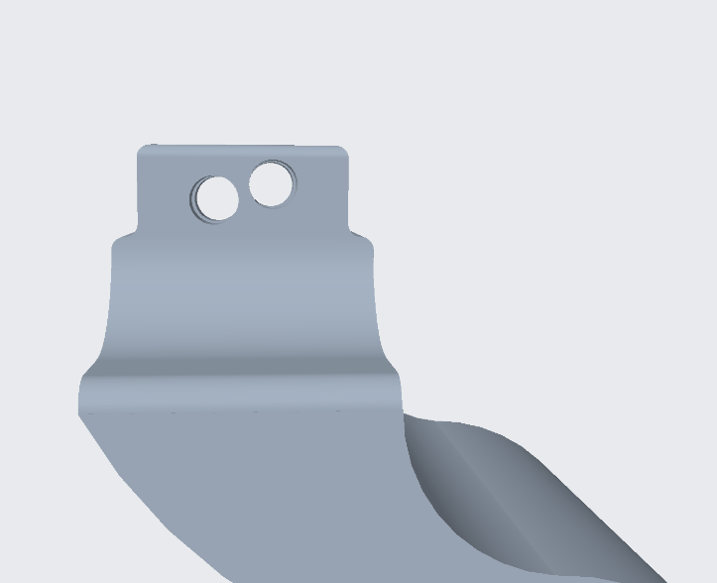
Figure 47: The area of integration

Figure 48: Addition of the lattice and traction to the foot

Appendix G: Engineering Drawings 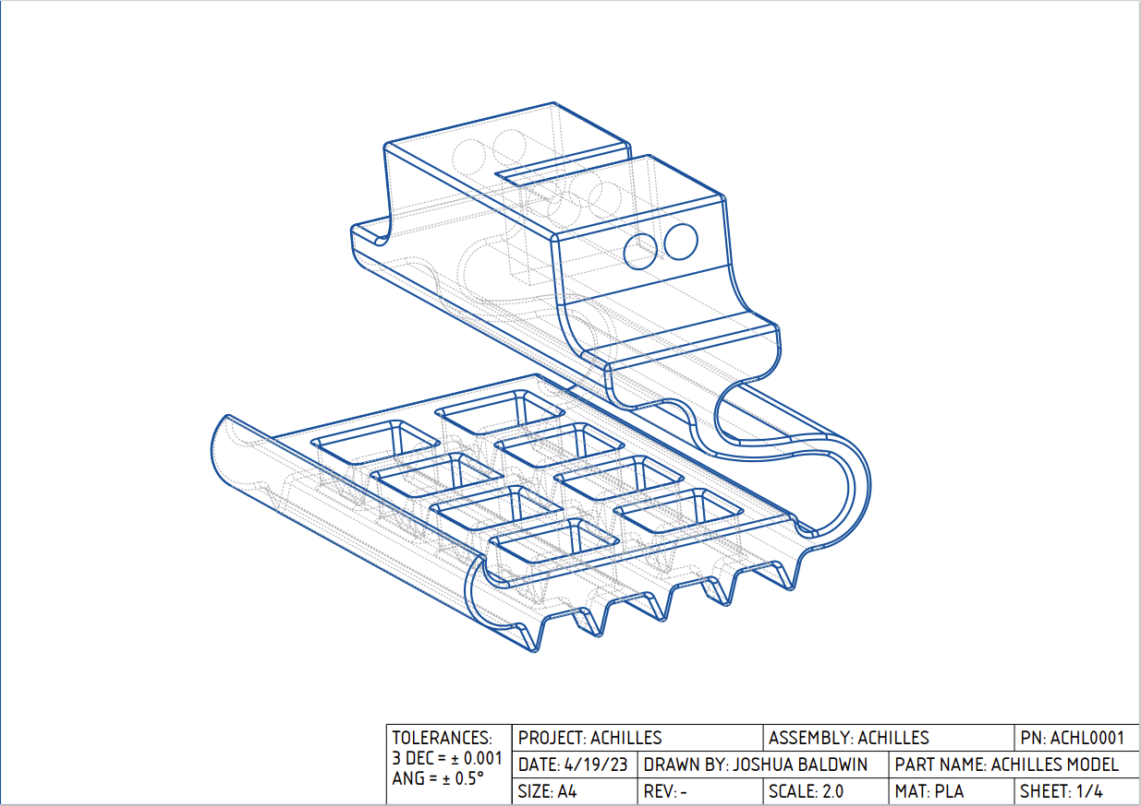
Achilles Model Drawings
ACHL0001
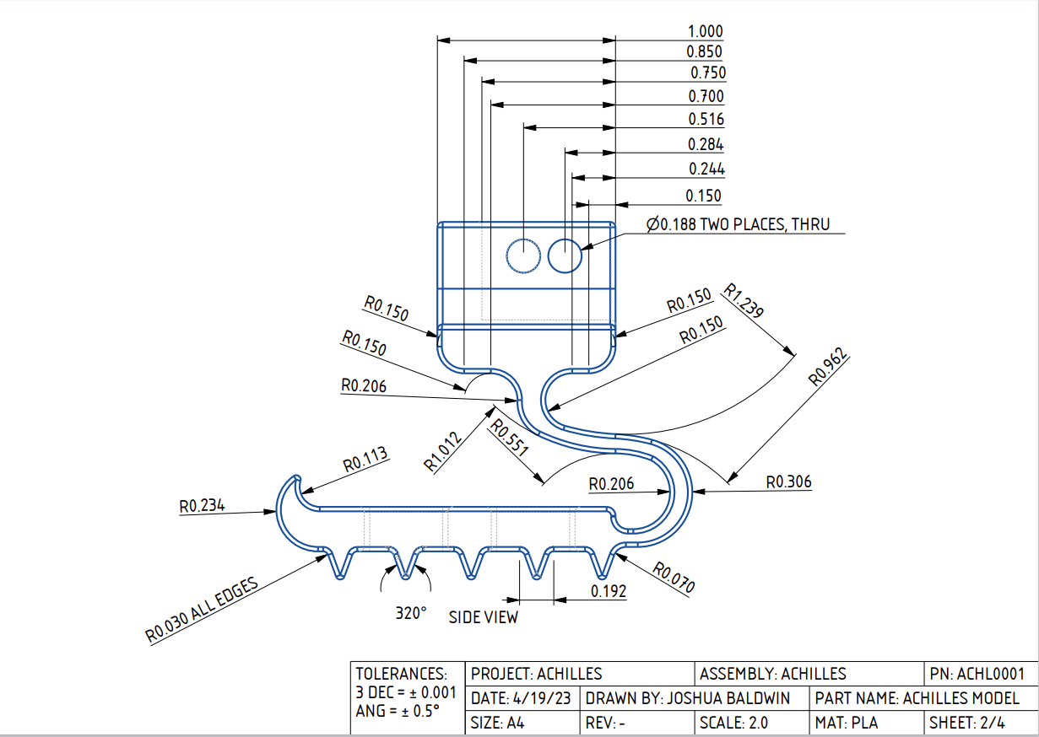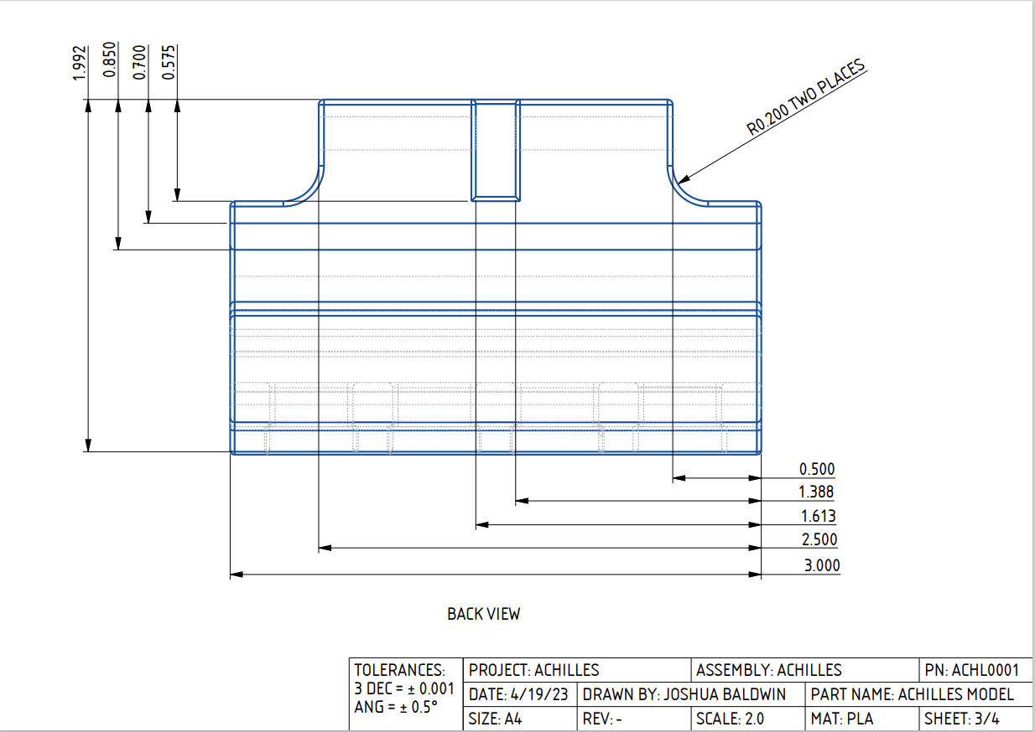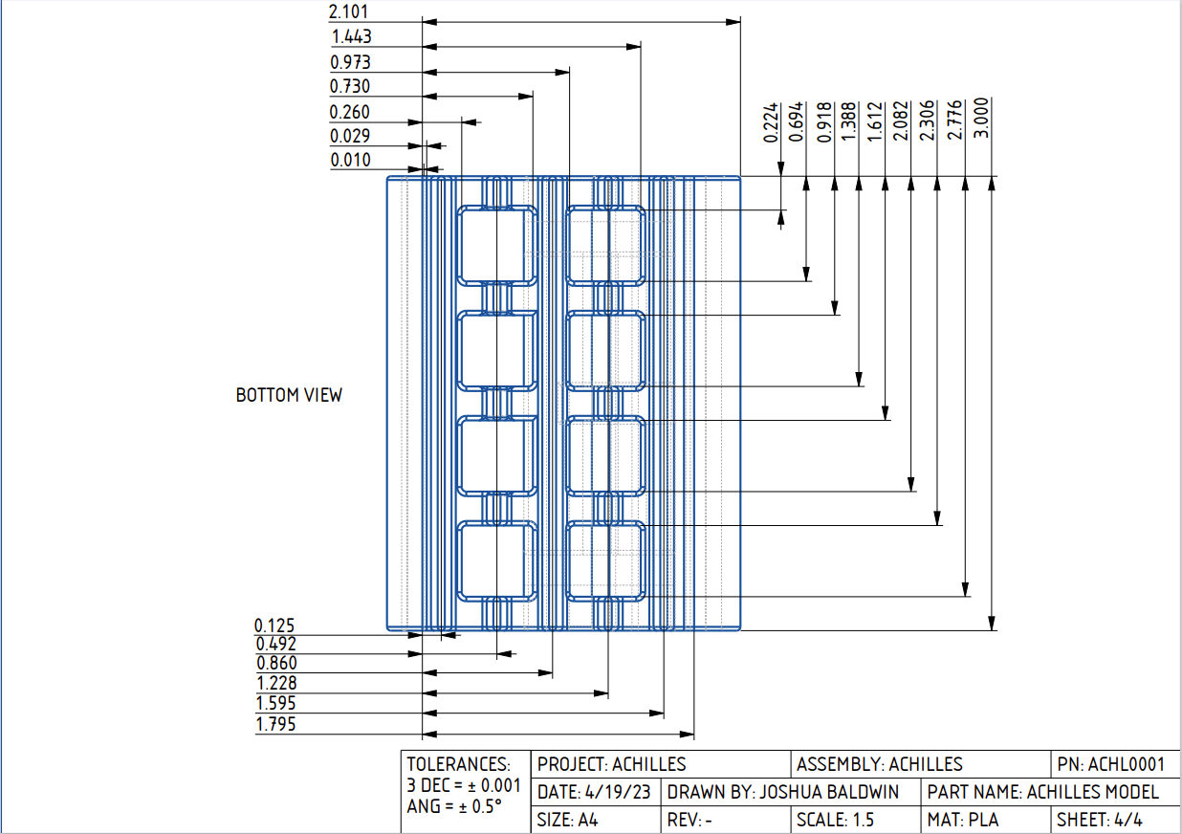

Regolith Displacement Test Assembly Drawings
Square 60% AR – RDTA0001
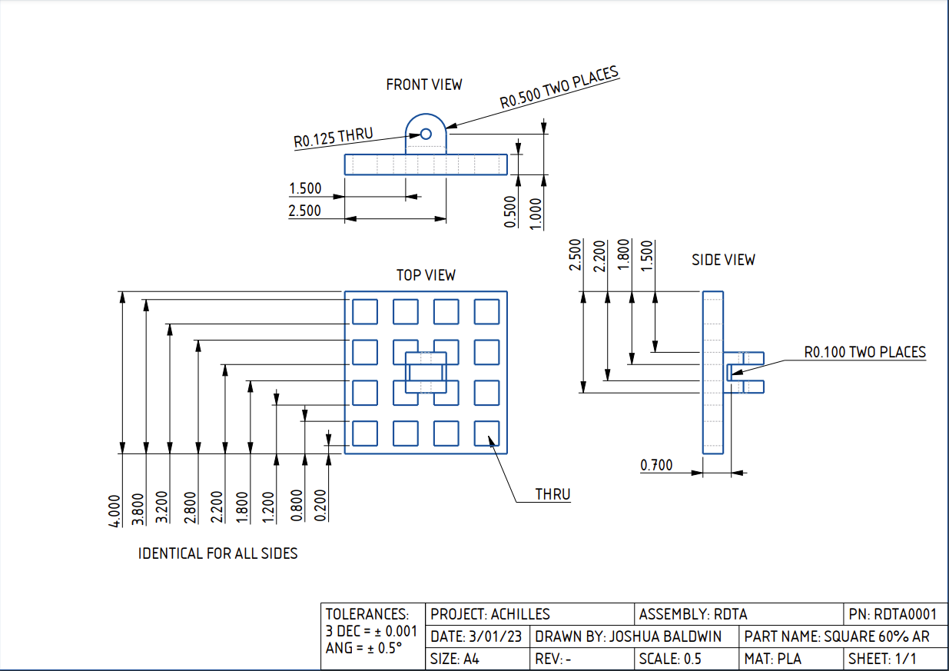
All drop test foot attachments had the same structural shape with variable lattice geometries

Bin Attachment – RDTA0002
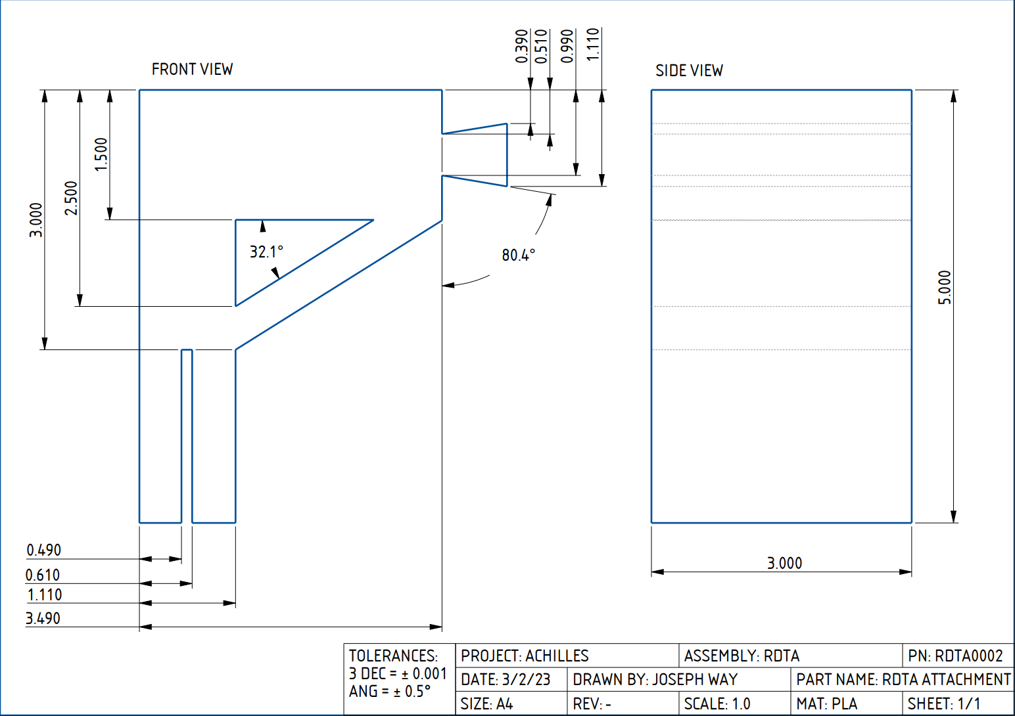

Guide Piece – RDTA0003
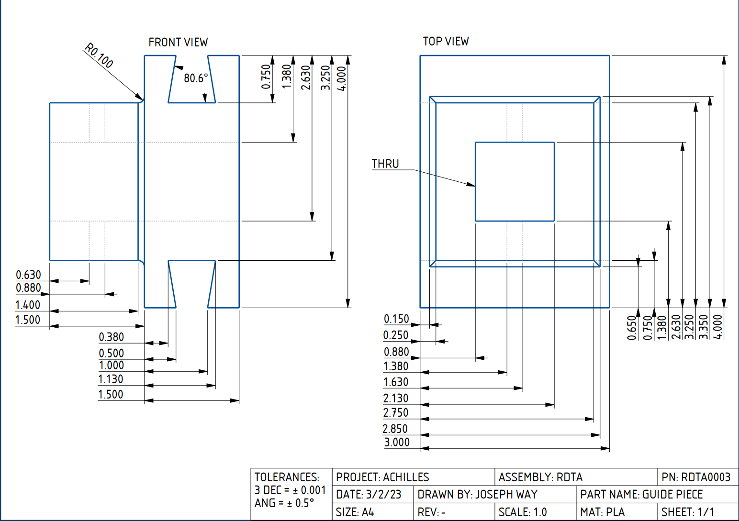
Dropping Device – RDTA0004
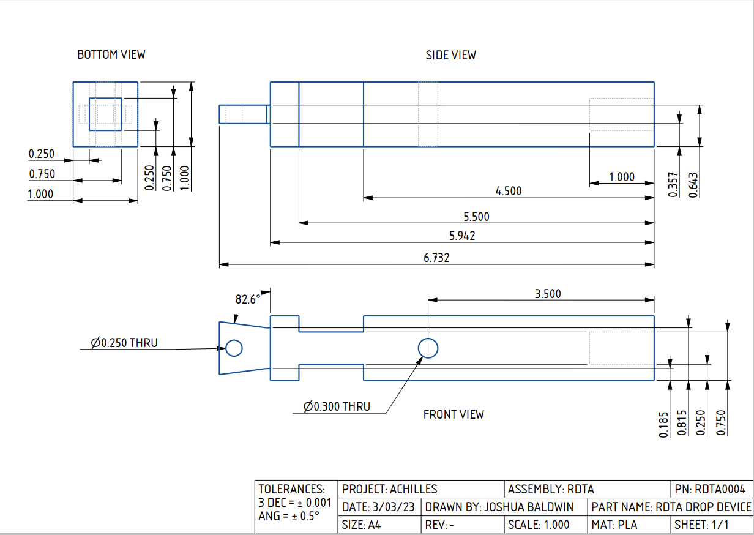

Support Shaft – RDTA0005
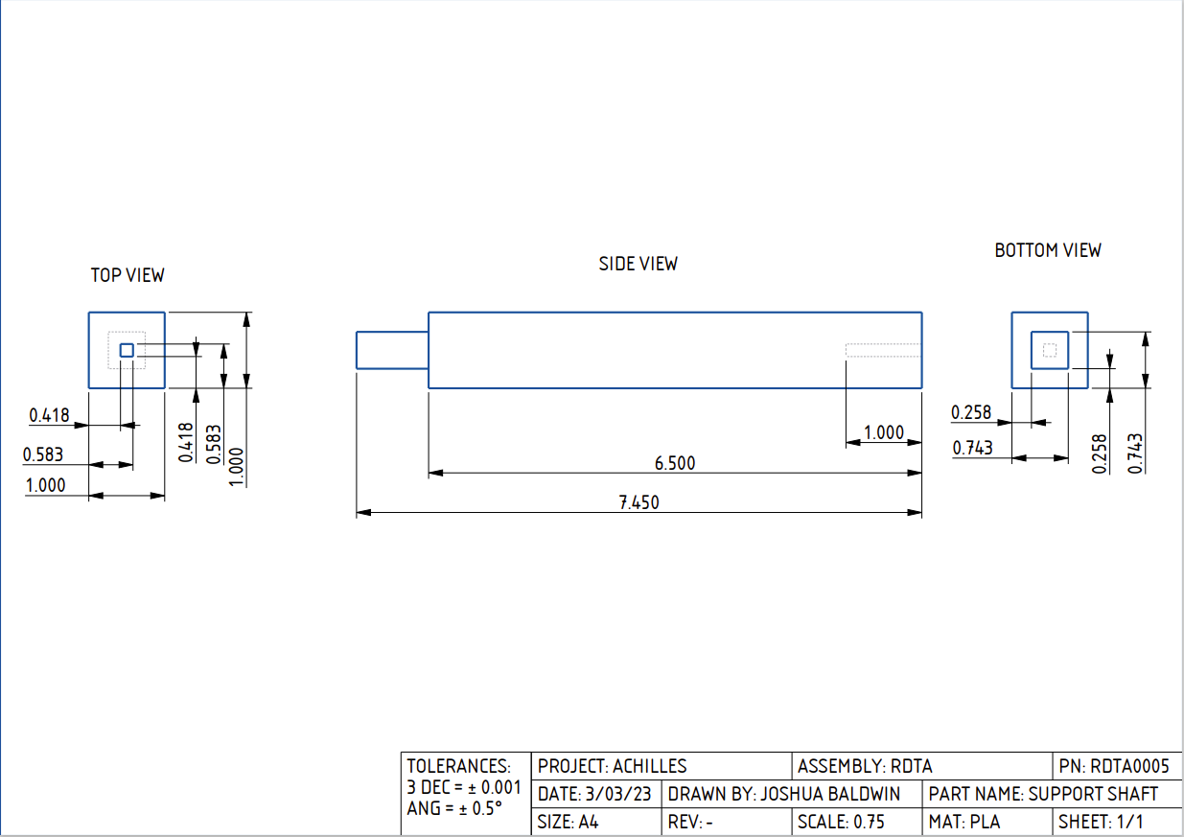

Traction Test Drawings
Spikes - TRAC0001
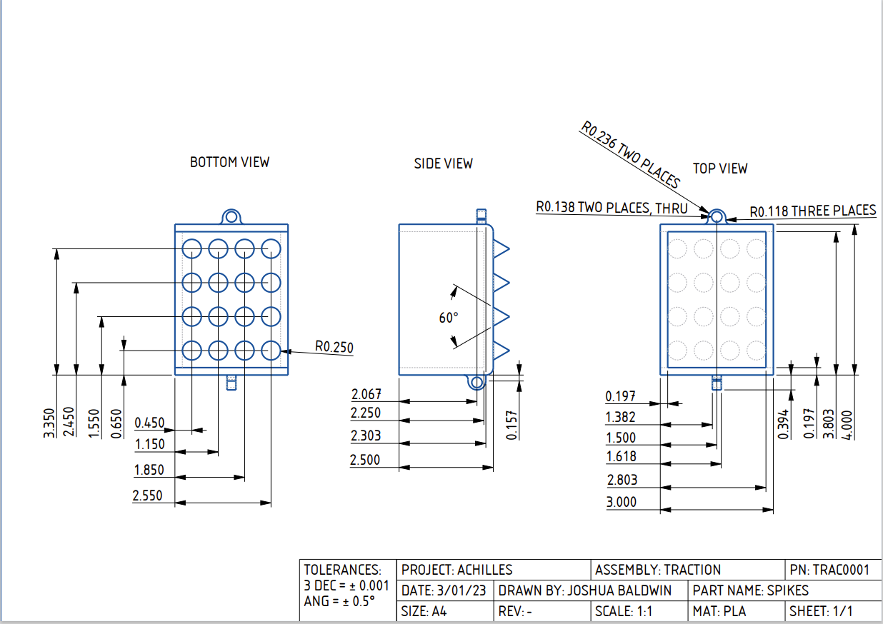

Claws – TRAC0002
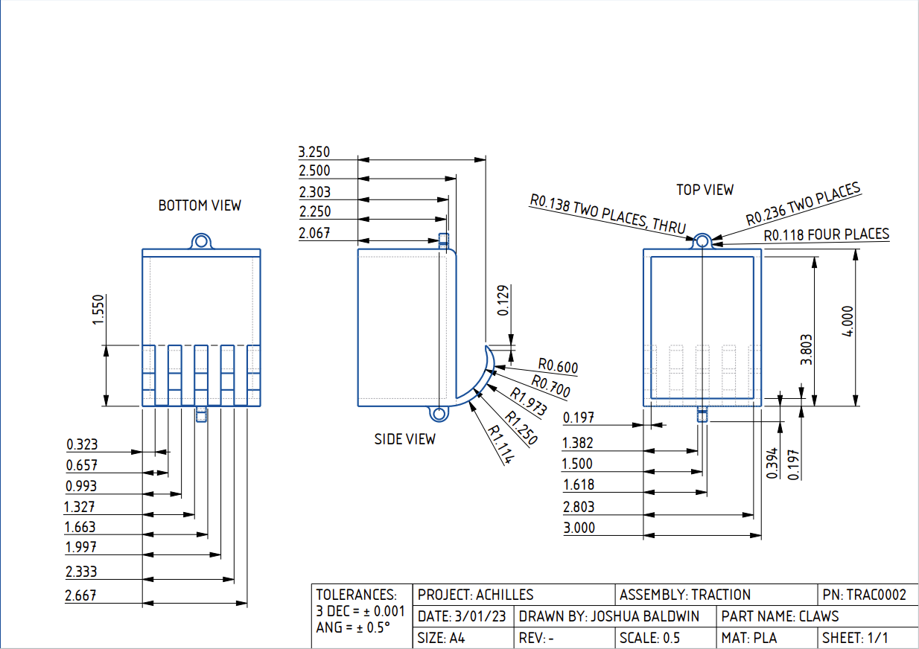

Combined Spikes and Hooks – TRAC0003
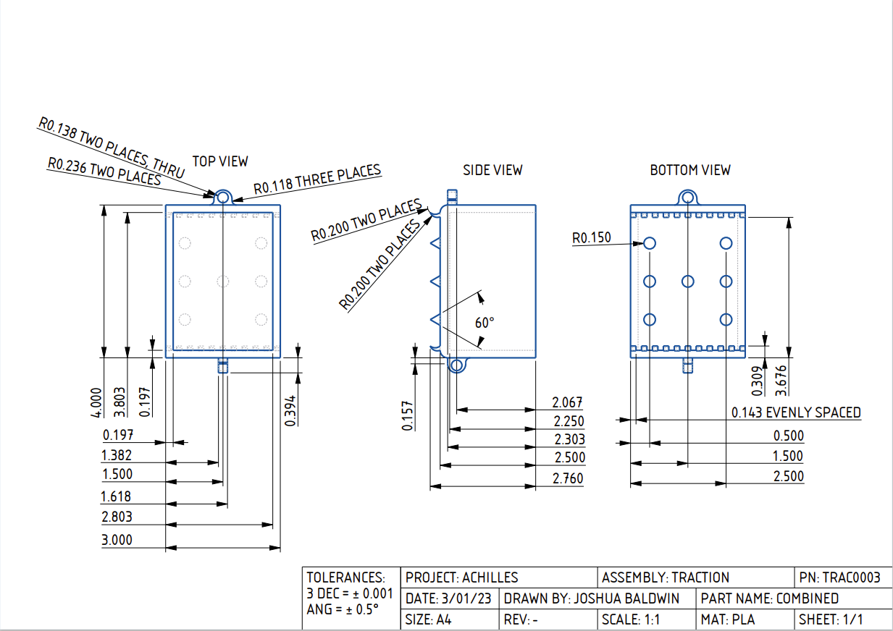

Cleats – TRAC0004
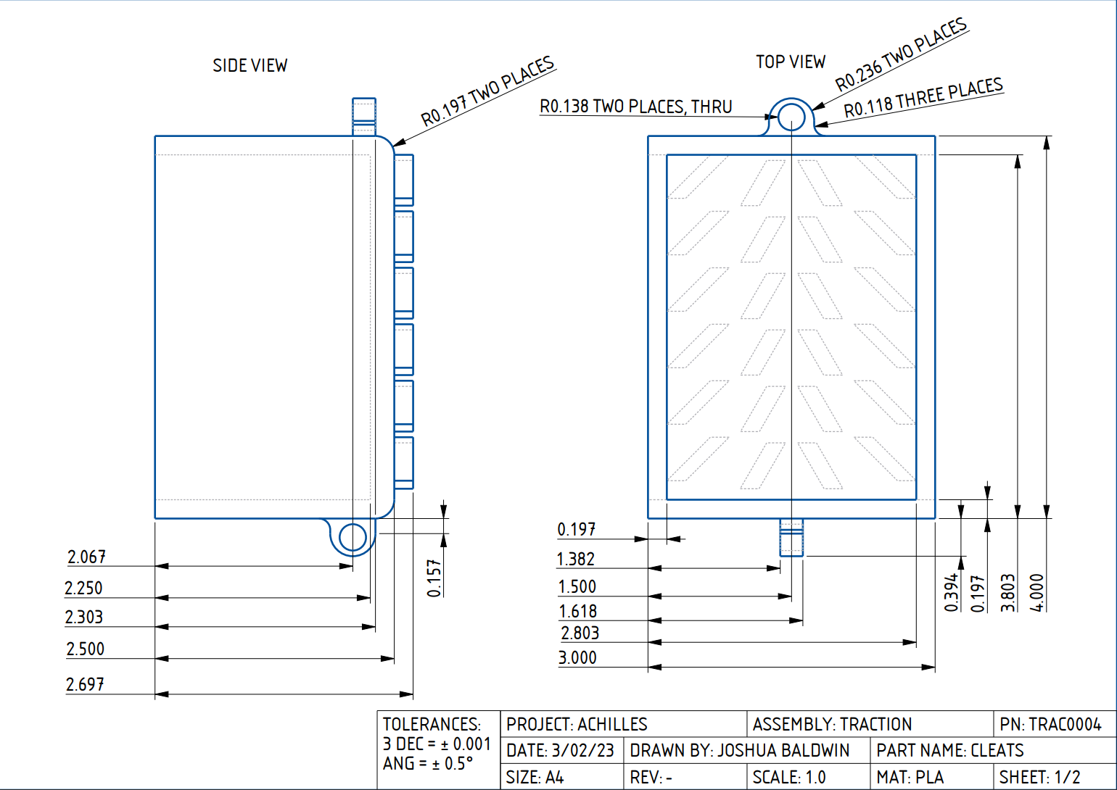
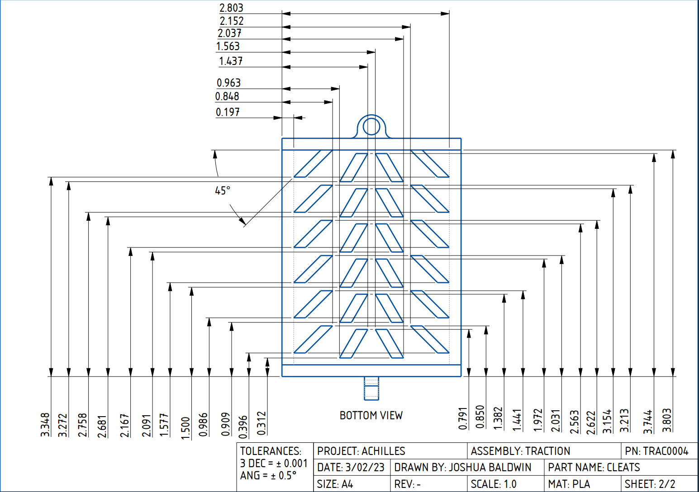

Hook and Rail – TRAC0005
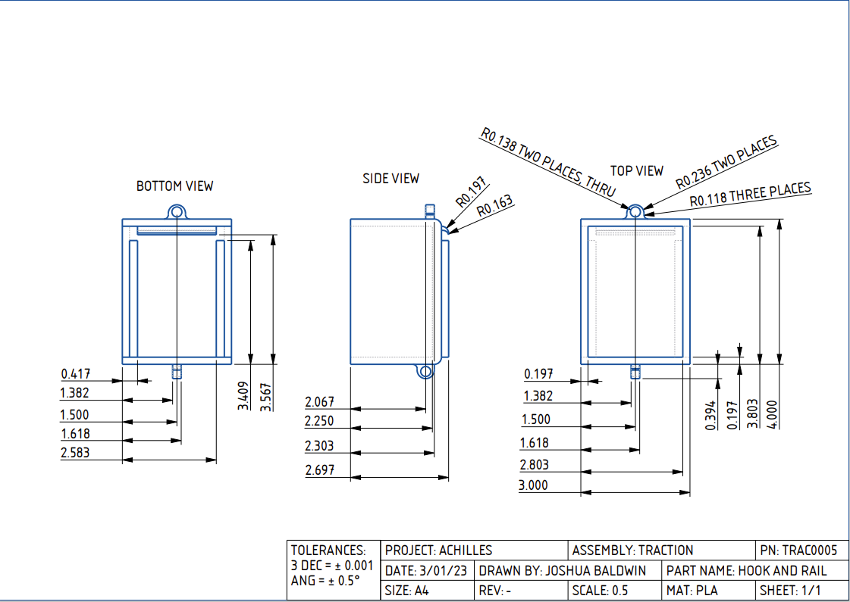

Appendix H: Risk Assessment

Lab Safety Expectations/ Rules Senior design projects provide wonderful hands-on experiences for students. The following safety rules will help to ensure every student has a safe, rewarding and valuable educational experience in the lab.
  - At least two people should be present in the lab when equipment and/or tools are in use.
• Always ask if you are unsure about something.
• Long pants and closed toed shoes are required in the lab when equipment and/or tools are in use.
• In the event of an injury or exposure to a chemical, regardless of severity, the lab user must report to the instructor and complete an accident report. In the event of serious/severe injuries or exposures call 9-1-1 immediately for medical attention.
• Do not attempt to remove foreign objects from the eye or body. Seek medical attention immediately. If chemicals are splashed into the eyes, utilize an eyewash station to rinse eyes for 15 minutes before seeking medical attention.
• Report any damage or missing parts to tools/equipment to the instructor immediately. • During repair, cleaning or oiling, machines and equipment MUST be shut off and locked out to ensure unauthorized startup does not occur.
• Neck ties, loose clothing, jewelry, gloves, etc. are prohibited around moving or rotating machinery. Long hair must be tied back or covered to keep it away from moving machinery.
• A brush, hook or specialized tool is preferred for removal of chips, shaving, etc. from work areas. Never use hands to clear work areas.
• Maintain the lab in a clean and orderly manner.
• Keep the floor clean, dry and free from trip and slip hazards.
• Food and drinks are prohibited in the lab.
• Review the Safety Data Sheet (SDS) for all chemicals used.
• Store oily rags in approved containers only.
• Used chemicals should never be poured down the drain or disposed outdoors. Contact Environmental Health & Safety for chemical disposal services.
• Clean up solvent and chemical spills immediately. In the event of a large spill, contact Environmental Health & Safety emergency response team for cleanup services.
• Know the location of the fire extinguisher, eyewash station, first aid kit, and fire escape route for your room. FAMU-FSU College of Engineering Project Hazard Assessment Policy and Procedures INTRODUCTION University laboratories are not without safety hazards. Those circumstances or conditions that might go wrong must be predicted and reasonable control methods must be determined to prevent incident and injury. The FAMU-FSU College of Engineering is committed to achieving and maintaining safety in all levels of work activities. PROJECT HAZARD ASSESSMENT POLICY Principal investigator (PI)/instructor are responsible and accountable for safety in the research and teaching laboratory. Prior to starting an experiment, laboratory workers must conduct a project hazard assessment (PHA) to identify health, environmental and property hazards, and the proper control methods to eliminate, reduce or control those hazards. PI/instructor must review, approve, and sign the written PHA and provide the identified hazard control measures. PI/instructor continually monitors projects to ensure proper controls and safety measures are available, implemented, and followed. PI/instructor are required to reevaluate a project anytime there is a change in scope or scale of a project and at least annually after the initial review. PROJECT HAZARD ASSESSMENT PROCEDURES It is FAMU-FSU College of Engineering policy to implement followings: 1. Laboratory workers (i.e., graduate students, undergraduate students, postdoctoral, volunteers, etc.) performing research in FAMU-FSU College of Engineering are required to conduct PHA prior to commencement of an experiment or any project change in order to identify existing or potential hazards and to determine proper measures to control those hazards. 2. PI/instructor must review, approve, and sign the written PHA. 3. PI/instructor must ensure all the control methods identified in PHA are available and implemented in the laboratory. 4. In the event laboratory personnel are not following the safety precautions, PI/instructor must take firm actions (e.g., stop the work, set a meeting to discuss potential hazards and consequences, ask personnel to review the safety rules, etc.) to clarify the safety expectations. 5. PI/instructor must document all the incidents/accidents that happened in the laboratory along with the PHA document to ensure that PHA is reviewed/modified to prevent reoccurrence. In the event of PHA modification a revision number should be given to the PHA, so project members know the latest PHA revision they should follow. 6. PI/instructor must ensure that those findings in PHA are communicated with other students working in the same laboratory (affected users). 7. PI/instructor must ensure that approved methods and precautions are being followed by: a. Performing periodic laboratory visits to prevent the development of unsafe practice. b. Quick reviewing of the safety rules and precautions in the laboratory members meetings. c. Assigning a safety representative to assist in implementing the expectations. d. Etc. 8. A copy of this PHA must be kept in a binder inside the laboratory or PI/instructor’s office (if experiment steps are confidential).
FAMU-FSU College of Engineering
Project Hazard Assessment Policy and Procedures
INTRODUCTION
University laboratories are not without safety hazards. Those circumstances or conditions that might go wrong must be predicted and reasonable control methods must be determined to prevent incident and injury. The FAMU-FSU College of Engineering is committed to achieving and maintaining safety in all levels of work activities.

PROJECT HAZARD ASSESSMENT POLICY
Principal investigator (PI)/instructor are responsible and accountable for safety in the research and teaching laboratory. Prior to starting an experiment, laboratory workers must conduct a project hazard assessment (PHA) to identify health, environmental and property hazards, and the proper control methods to eliminate, reduce or control those hazards. PI/instructor must review, approve, and sign the written PHA and provide the identified hazard control measures. PI/instructor continually monitors projects to ensure proper controls and safety measures are available, implemented, and followed. PI/instructor are required to reevaluate a project anytime there is a change in scope or scale of a project and at least annually after the initial review.

PROJECT HAZARD ASSESSMENT PROCEDURES
It is FAMU-FSU College of Engineering policy to implement followings:
- Laboratory workers (i.e., graduate students, undergraduate students, postdoctoral, volunteers, etc.) performing research in FAMU-FSU College of Engineering are required to conduct PHA prior to commencement of an experiment or any project change in order to identify existing or potential hazards and to determine proper measures to control those hazards.
- PI/instructor must review, approve, and sign the written PHA.
- PI/instructor must ensure all the control methods identified in PHA are available and implemented in the laboratory.
- In the event laboratory personnel are not following the safety precautions, PI/instructor must take firm actions (e.g., stop the work, set a meeting to discuss potential hazards and consequences, ask personnel to review the safety rules, etc.) to clarify the safety expectations.
- PI/instructor must document all the incidents/accidents that happened in the laboratory along with the PHA document to ensure that PHA is reviewed/modified to prevent reoccurrence. In the event of PHA modification a revision number should be given to the PHA, so project members know the latest PHA revision they should follow.
- PI/instructor must ensure that those findings in PHA are communicated with other students working in the same laboratory (affected users).
- PI/instructor must ensure that approved methods and precautions are being followed by:
  - Performing periodic laboratory visits to prevent the development of unsafe practice.
  - Quick reviewing of the safety rules and precautions in the laboratory members meetings.
  - Assigning a safety representative to assist in implementing the expectations.
  - Etc.
- A copy of this PHA must be kept in a binder inside the laboratory or PI/instructor’s office (if experiment steps are confidential).

Project Hazard Assessment Worksheet
PI/instructor: Dr. McConomy | Phone #: 850-410-6624 | Dept.: Mechanical | Start Date: 11/16/2022 | Revision number: 1
Project: Team 518 Lunar Surface 2 |  |  | Location(s): FAMU-FSU College of Engineering
Team member(s): Joshua Baldwin, Enrique Chocron, Emily Dawson, Andres Hernandez, Joseph Way |  |  | Phone #: 303-810-9341 | Email: erd18b@fsu.edu

Experiment Steps | Location | Person assigned | Identify hazards or potential failure points | Control method | PPE | List proper method of hazardous waste disposal, if any. | Residual Risk | Specific rules based on the residual risk
3D Printing | ME - Senior Design Lab  Room: A212 | Joshua | Burns from hot PLA material, breathing harmful materials. | Operating the printer with proper air circulation. | N/A | Dispose of the material into the appropriate waste receptacle. | HAZARD: 1  CONSEQ:  Negligible | All PPE must be applied before the soldering device is turned on. Safety controls are planned by both the worker and supervisor. Proceed with supervisor authorization
Residual:
Low
Machining Parts | Machine shop room number | All team members | Frayed or damaged electrical cords, machinery with exposed moving parts. Sharp corners from materials may cause minor cuts and bruises. | If a group member is doing the metal work, another person will be present. Members will not wear loose clothing or jewelry while machining. Members must also work in a well-ventilated environment | Safety glasses, close-toed shoes, long pants | Wipe down all tables and sweep the floors to ensure no metal scraps are left behind. | HAZARD: 3  CONSEQ:  Significant | OSHA requires safety glasses to be worn when the user may be subjected to flying particles
Residual:
Medium
High
Regolith Simulant Resistive Media | NASA – MSFC  Huntsville, AL | All team members | There are two types of regolith simulant. Health hazards occur with the fine dust-like simulant. It can cause eye and lung irritation. | The larger grain regolith can be used in an enclosed but well vented environment. The dusty regolith needs to be in an open-air facility. | Mask, gloves, and safety glasses. | N/A | HAZARD: 2  CONSEQ:  Minor | PPE for the dusty regolith will be worn including safety glasses and a mask. NASA and NIOSH recommend being in a well-ventilated area and using an approved dust respirator for longer exposer times.
Residual:
Low Medium
Assembly | ME - Senior Design Lab  Room: A212 | Andres | Receiving cuts from tools,  Soldering burn/fumes, and electrocution. | The system has chassis grounding to route unwanted and potentially dangerous current away from the system elements and to protect anyone. Use of a heat shrink and proper insulation to prevent short circuits. | Safety glasses, gloves, masks, and closed-toed shoes. | Battery disposal and Disposing material in their appropriate waste/recycling receptacle | HAZARD: 2  CONSEQ:  Minor | Safety controls are planned by both the worker and supervisor. A second worker must be in place before work can proceed (buddy system). Proceed with supervisor authorization.
Residual:
Low Medium
General Prototyping | ME - Senior Design Lab  Room: A212 | All team members | Eye and skin irritation and small cuts. | Use the buddy system as well as being in an isolated environment. | N/A | Wipe down all tables and dispose of any extra materials. | HAZARD:1  CONSEQ:  Negligible | Safety controls are planned by both the worker and supervisor. Proceed with supervisor authorization.
Residual:
Low
Testing | AME Building | All team members | Pinching, minor cuts and bruises, small debris. May also cause eye and lung irritation | Testing should be done in the designated testing apparatus. | Mask, closed-toed shoes, long pants, safety glasses. | N/A | HAZARD:3  CONSEQ:  Moderate | Cautionary steps to complete testing with thorough analysis. This is done with planning steps beforehand and preparing needs.
Residual:
Medium
CAD and Coding | Multiple locations | Joseph  Joshua  Andres | Prolonged exposure to looking at a computer screen for more than 20 minutes can cause eye irritation, headaches, dry eyes, and neck/back pain | Take breaks every 20 minutes. Walk around and stretch | N/A | N/A | HAZARD: 1  CONSEQ:  Negligible | Drawings are done through computer aided design. This could have long term effects on muscles and eye strain.
Residual:
Low
Transportation of Equipment | Multiple locations | Emily | Car collision | A safe, non-distracted driver, everyone is wearing seatbelts | Seatbelts | N/A | HAZARD: 2  CONSEQ:  Significant | Seatbelts are to be worn while driving and protective coverings on materials will be used.
Residual:
Medium

Principal investigator(s)/ instructor PHA: I have reviewed and approved the PHA worksheet.
Name | Signature | Date | Name | Signature | Date
_____________________________ | ____________________ | ____________ | ______________________________ | ____________________ | __________
Team members: I certify that I have reviewed the PHA worksheet, am aware of the hazards, and will ensure the control measures are followed.
Name | Signature | Date | Name | Signature | Date
Joshua Baldwin | Joshua Baldwin | 03/03/23 | Emily Dawson | Emily Dawson | 03/03/23
Enrique Chocron | Enrique Chocron | 03/03/23 | Andres Hernandez | Andres Hernandez | 03/03/23
Joseph Way | Joseph Way | 03/03/23 |  | ____________________ | ____________

Copy this page if more space is needed.

DEFINITIONS:
Hazard: Any situation, object, or behavior that exists, or that can potentially cause ill health, injury, loss or property damage e.g. electricity, chemicals, biohazard materials, sharp objects, noise, wet floor, etc. OSHA defines hazards as “any source of potential damage, harm or adverse health effects on something or someone". A list of hazard types and examples are provided in appendix A.
Hazard control: Hazard control refers to workplace measures to eliminate/minimize adverse health effects, injury, loss, and property damage. Hazard control practices are often categorized into following three groups (priority as listed):
- Engineering control: physical modifications to a process, equipment, or installation of a barrier into a system to minimize worker exposure to a hazard. Examples are ventilation (fume hood, biological safety cabinet), containment (glove box, sealed containers, barriers), substitution/elimination (consider less hazardous alternative materials), process controls (safety valves, gauges, temperature sensor, regulators, alarms, monitors, electrical grounding and bonding), etc.
- Administrative control: changes in work procedures to reduce exposure and mitigate hazards. Examples are reducing scale of process (micro-scale experiments), reducing time of personal exposure to process, providing training on proper techniques, writing safety policies, supervision, requesting experts to perform the task, etc.
- Personal protective equipment (PPE): equipment worn to minimize exposure to hazards. Examples are gloves, safety glasses, goggles, steel toe shoes, earplugs or muffs, hard hats, respirators, vests, full body suits, laboratory coats, etc.
Team member(s): Everyone who works on the project (i.e. grads, undergrads, postdocs, etc.). The primary contact must be listed first and provide phone number and email for contact.
Safety representative: Each laboratory is encouraged to have a safety representative, preferably a graduate student, in order to facilitate the implementation of the safety expectations in the laboratory. Duties include (but are not limited to):
- Act as a point of contact between the laboratory members and the college safety committee members.
- Ensure laboratory members are following the safety rules.
- Conduct periodic safety inspection of the laboratory.
- Schedule laboratory clean up dates with the laboratory members.
- Request for hazardous waste pick up.
Residual risk: Residual Risk Assessment Matrix is used to determine a project’s risk level. The hazard assessment matrix (table 1) and the residual risk assessment matrix (table2) are used to identify the residual risk category.
The instructions to use hazard assessment matrix (table 1) are listed below:
- Define the workers familiarity level to perform the task and the complexity of the task.
- Find the value associated with familiarity/complexity (1 – 5) and enter value next to: HAZARD on the PHA worksheet.
Table 1. Hazard assessment matrix.
 |  | Complexity
 |  | Simple | Moderate | Difficult
Familiarity Level | Very Familiar | 1 | 2 | 3
 | Somewhat Familiar | 2 | 3 | 4
 | Unfamiliar | 3 | 4 | 5

The instructions to use residual risk assessment matrix (table 2) are listed below:
- Identify the row associated with the familiarity/complexity value (1 – 5).
- Identify the consequences and enter value next to: CONSEQ on the PHA worksheet. Consequences are determined by defining what would happen in a worst-case scenario if controls fail.
  - Negligible: minor injury resulting in basic first aid treatment that can be provided on site.
  - Minor: minor injury resulting in advanced first aid treatment administered by a physician.
  - Moderate: injuries that require treatment above first aid but do not require hospitalization.
  - Significant: severe injuries requiring hospitalization.
  - Severe: death or permanent disability.
- Find the residual risk value associated with assessed hazard/consequences: Low –Low Med – Med– Med High – High.
- Enter value next to: RESIDUAL on the PHA worksheet.
Table 2. Residual risk assessment matrix.
Assessed  Hazard Level | Consequences
 | Negligible | Minor | Moderate | Significant | Severe
5 | Low Med | Medium | Med High | High | High
4 | Low | Low Med | Medium | Med High | High
3 | Low | Low Med | Medium | Med High | Med High
2 | Low | Low Med | Low Med | Medium | Medium
1 | Low | Low | Low Med | Low Med | Medium

Specific rules for each category of the residual risk:
Low:
- Safety controls are planned by both the worker and supervisor.
- Proceed with supervisor authorization.
Low Med:
- Safety controls are planned by both the worker and supervisor.
- A second worker must be in place before work can proceed (buddy system).
- Proceed with supervisor authorization.
Med:
- After approval by the PI, a copy must be sent to the Safety Committee.
- A written Project Hazard Control is required and must be approved by the PI before proceeding. A copy must be sent to the Safety Committee.
- A second worker must be in place before work can proceed (buddy system).
- Limit the number of authorized workers in the hazard area.
Med High:
- After approval by the PI, the Safety Committee and/or EHS must review and approve the completed PHA.
- A written Project Hazard Control is required and must be approved by the PI and the Safety Committee before proceeding.
- Two qualified workers must be in place before work can proceed.
- Limit the number of authorized workers in the hazard area.
High:
- The activity will not be performed. The activity must be redesigned to fall in a lower hazard category.

Appendix A: Hazard types and examples
Types of Hazards | Example
Physical hazards | Wet floors, loose electrical cables objects protruding in walkways or doorways
Ergonomic hazards | Lifting heavy objects Stretching the body  Twisting the body  Poor desk seating
Psychological hazards | Heights, loud sounds, tunnels, bright lights
Environmental hazards | Room temperature, ventilation contaminated air, photocopiers, some office plants acids
Hazardous substances | Alkalis solvents
Biological hazards | Hepatitis B, new strain influenza
Radiation hazards | Electric welding flashes Sunburn
Chemical hazards | Effects on central nervous system, lungs, digestive system, circulatory system, skin, reproductive system. Short term (acute) effects such as burns, rashes, irritation, feeling unwell, coma and death.  Long term (chronic) effects such as mutagenic (affects cell structure), carcinogenic (cancer), teratogenic (reproductive effect), dermatitis of the skin, and occupational asthma and lung damage.
Noise | High levels of industrial noise will cause irritation in the short term, and industrial deafness in the long term.
Temperature | Personal comfort is best between temperatures of 16°C and 30°C, better between 21°C and 26°C.  Working outside these temperature ranges: may lead to becoming chilled, even hypothermia (deep body cooling) in the colder temperatures, and may lead to dehydration, cramps, heat exhaustion, and hyperthermia (heat stroke) in the warmer temperatures.
Being struck by | This hazard could be a projectile, moving object or material. The health effect could be lacerations, bruising, breaks, eye injuries, and possibly death.
Crushed by | A typical example of this hazard is tractor rollover. Death is usually the result
Entangled by | Becoming entangled in machinery. Effects could be crushing, lacerations, bruising, breaks amputation and death.
High energy sources | Explosions, high pressure gases, liquids and dusts, fires, electricity and sources such as lasers can all have serious effects on the body, even death.
Vibration | Vibration can affect the human body in the hand arm with `white finger' or Raynaud's Syndrome, and the whole body with motion sickness, giddiness, damage to bones and audits, blood pressure and nervous system problems.
Slips, trips and falls | A very common workplace hazard is from tripping on floors, falling off structures or downstairs, and slipping on spills.
Radiation | Radiation can have serious health effects. Skin cancer, other cancers, sterility, birth deformities, blood changes, skin burns, and eye damage are examples.
Physical | Excessive effort, poor posture and repetition can all lead to muscular pain, tendon damage and deterioration to bones and related structures
Psychological | Stress, anxiety, tiredness, poor concentration, headaches, back pain and heart disease can be the health effects
Biological | More common in the health, food and agricultural industries. Effects such as infectious disease, rashes and allergic response.

Project Hazard Control- For Projects with Medium and Higher Risks
Name of Project: |  |  |  | Date of submission:
Team member |  | Phone number |  | e-mail
Joshua Baldwin |  | 407-403-2086 |  | jpb18@fsu.edu
Enrique Chocron |  | 954-544-8810 |  | eac17e@fsu.edu
Emily Dawson |  | 303-810-9341 |  | erd18b@fsu.edu
Andres Hernandez Chapa |  | 786-860-3175 |  | ahernandezchapa@fsu.edu
Joseph Way |  | 850-273-2911 |  | joseph1.way@famu.edu
Faculty mentor |  | Phone number |  | e-mail
Shayne McConomy |  | 850-410-6624 |  | smcconomy@eng.famu.fsu.edu
Rewrite the project steps to include all safety measures taken for each step or combination of steps. Be specific (don’t just state “be careful”).
During General Prototyping, the possible risks include small cuts, skin and inhalation irritation. The safety measures include being in a closed, well-ventilated environment and having multiple people working on the project simultaneously.

CAD presents negligible risk; however possible long-term issues could arise such as eye strain and back problems. We will take breaks to mitigate problems occurring in this stage.

3D Printing presents low risk, but situations involving burns from hot components can happen. We will satisfy the safety in this stage by avoiding touching scalding parts and working in a well-ventilated environment.

Any testing for the rover has a medium risk. Potential injuries include minor cuts, bruises, pinching, and debris injuries. Safe distances during testing and proper clothing including closed-toed shoes will be worn to help combat these possible risks.

Machining Parts presents a medium-high risk. Potential injuries may include cuts, bruises, pinches, and other injuries from debris. To help mitigate these risks, a minimum of two people will be present in the machine shop. Also, the people machining parts will wear the proper PPE, including close-toed shoes, safety glasses, and no loose-fitting clothing. Another step to help mitigate injuries is proper clean-up. Once the parts are done being machined, all metal shaving will be cleaned up and thrown away.

Assembling the project presents a minor risk. Potential injuries include cuts from tools, as well as burns from soldering or electrical aspects. Mitigation will be done using PPE, grounding all circuits, and ensuring more than one person is working on the assembly at a time.

Regolith Simulant Resistive Media presents a low-medium risk while using two different simulants. The first simulant is a larger grain size and presents negligible risk. The second type of regolith simulant is more dust-like and issues can occur when it is inhaled. To combat the risk of the dusty simulant, anyone around the simulant while tests are being conducted will wear safety glasses and a mask. The testing involved with the dusty regolith needs to occur in a non-enclosed facility.

At the end of the semester, this project may be transported up to the NASA-MSCF facility for final testing and validation. Transportation of equipment presents a medium risk. Potential injuries include any injury that could occur in a car accident: cuts, bruises, broken bones etc. To limit the possibility of injury, safe driving techniques will be observed by the driver, and everyone will wear their seatbelts.

Thinking about the accidents that have occurred or that you have identified as a risk, describe emergency response procedures to use.
- Remove the injured individual from the area if safe and possible
- Immediately shut down and stop the activity that caused an injury
- Secure the area to ensure no one else can get injured.
- If it is a minor injury, treat with first aid knowledge
- Contact proper authority (FSUPD, Supervisor, etc)
- Contact the individual's emergency contact and update them on the situation.
- Create an Accident Report

List emergency response contact information:
- Call 911 for injuries, fires or other emergency situations
- Call your department representative to report a facility concern
Name | Phone number |  | Faculty or other COE emergency contact |  | Phone number
Connie Baldwin | 321-228-9331 |  | Shayne McConomy |  | 850-410-6624
Maria Hernandez | 713-775-3223 |  | Jonathan Clark |  | 850-410-6608
Christine Dawson | 720-244-3735
Nicole Richardson-Way | 904-240-6924
Eduardo Chocron | 954-544-8842
Safety review signatures
Team member | Date |  | Faculty mentor |  | Date
Joshua Baldwin | 03/03/2023
Enrique Chocron | 03/03/2023
Emily Dawson | 03/03/2023
Andres Hernandez | 03/03/2023
Joseph Way | 03/03/2023
Report all accidents and near misses to the faculty mentor.

Appendix I: Calculations

Below are examples of the calculations done to acquire the dynamic coefficient of friction and the spring constant.

The basic equation for friction force is:
$$F_{f}=μ_{k}*N$$
We also know that
$$N=mg$$
For this example, the combined mass of the foot design and added weight is 0.174 grams and gravity is 9.81 $\frac{m}{s^{2}}$. Plugging these values in we obtain
$$N=\left(0.174\right)\left(9.81\right)$$
$N=1.706$N
Through the traction test, the $F_{f}$ was determined to be 1.601 N. Now solving for $μ_{k}$:

$$μ_{k}=\frac{F_{f}}{N}$$
$$μ_{k}=\frac{1.601}{1.706}$$

And using this equation we were able to obtain the coefficients of friction for each foot design
$$μ_{k}=0.94$$

Table 16: Static and dynamic coefficients of friction
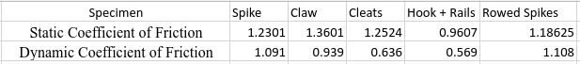

The equation for the spring constant is:
$$k=\frac{F}{x}$$
Where F is the force, x is the distance the spring gets longer or shorter, and k is the spring constant. To find the spring constant of the foot design we ran three tests using
$$k =\frac{\left(k_{1}+k_{2}+k_{3}\right)}{3}$$
To obtain the average spring constant and acquired forces of 13.34 N, 17.79 N, and 14.46 N from the force gauge and the displacement from each test was 12.7 mm. Plugging these values in we obtain the average spring constant as
$k_{1} =\frac{13.34}{12.7}=1.05$ N
$k_{2} =\frac{17.79}{12.7}=1.40$ N
$k_{3} =\frac{14.46}{12.7}=1.14$ N
$$k =\frac{1.05+1.40+1.14}{3}$$
$$k = 1.20 \frac{N}{mm}$$

Appendix J: Plume Data Code
% FAMU-FSU College of Engineering - Department of Mechanical Engineering
% EML4552C - Senior Design II
% T518 NASA-MSFC Movement Through Deep Regolith

% REGOLITH PLUME PROFILE IDENTIFIER
% This MATLAB code imports a JPG, converts the figure to a binary figure,
% and determines the ratio between black and white.

% Written by: Andres Hernandez Chapa
% Date: 02/12/2023

clc
% Prompt the user to select an image file
[file,path] = uigetfile('*.jpg','Select an image file');

% Read in the image file and convert it to grayscale
image = rgb2gray(imread(fullfile(path,file)));

% Convert the grayscale image to a binary image
bw_image = imbinarize(image);

% Number of pixels in the binary image
num_pixels = numel(bw_image);

% Determine the ratio of black to white pixels in the binary image
num_white = nnz(bw_image);
num_black = numel(bw_image) - num_white;

% White percentage in the ROI (Regolith Plumes)
regolith_plumes_percentage = num_white/num_pixels;

% Black percentage in the ROI (Regolith Plumes)
black_area_percentage = num_black/num_pixels;

% Display the results
disp(['The calculations have been performed on file ', file]);
disp(['White percentage in the image: ', num2str(regolith_plumes_percentage)]);

